GOOGLE PLAYSTORE APP RATING
PREDICTION
Object Oriented Software Engineering Lab
By
P. AKHILA NAGA VENKATA MADHURI | 2441151
P. JEEVANA JYOTHI | 2441152
P. BALAGANI SWAMY | 2441153
REVANTH.A | 2441154
R. PANDU RANGA RAO | 2441155
R. SIVA MANOHAR RAJU | 2441156
S. SAHITHI | 2441157
S. JAHNAVI | 2441158
S. SANTHOSH KUMAR | 2441159
S. VARALAKSHMI DURGA | 2441160
V. SATYANARAYANA | 2441161
S. HARI VARMA | 2441162
S. BILAAL | 2441163
S. SATYA BHARGAVI | 2441164
S. NAVAB SHAREEF | 2441165

DEPARTMENT OF COMPUTER SCIENCE
P. G. COURSES AND RESEARCHCENTER DNR.COLLEGE
(Affiliated to Adikavi Nannaya University)
BHIMAVARAM-534201
DEPARTMENT OF COMPUTER SCIENCE
P.G. COURSES AND RESEARCH CENTRE
D.N.R. COLLEGE
(Reaccredited at 'B++' grade by NAAC)
(Affiliated to Adikavi Nannaya University)
BHIMAVARAM-534201
CERTIFICATE
This is to certify that the "Object Oriented Software Engineering Lab" entitled
"GOOGLE PLAYSTORE APP RATING PREDICTION" Submitted by Revu pandu ranga rao Regd. No. 2441155 of II M.C.A III Semester has been done during the academic year
2024-2025.
Internal Examiner Head of the department

External Examiner

GOOGLE PLAYSTORE APP RATING PREDICTION

INDEX
Contents | Page no.
Abstract  - INTRODUCTION  - Introduction  - Analysis and prediction of google play store app  - Google play store data  - Machine learning  - HADOOP distributed file system  - Deep leaming  - Neural networks  - machine learning vs deep learning  - Why deep leaming?  - Problem statement  - Objective  - Methodology  - Analysis  - Prediction  - Literature survey  - Big data techniques for efficient storage and processing of weather  - Commercial product and analysis using HADOOP map reduce  - Review paper on HADOOP and map reduce  - Analysis of twitter data within big data distributed Environment  - PYTHON-The fastest growing programming language  - Machine learning algorithms: A review  - An overview of deep learning  - The power of Mobile Applications  - Mobile App Analytics  - System Development  - Designing  - Architecture  - Machine Learning architecture  - HDFS architecture  - Data Flow  - Data flow in machine learning  - Data flow in deep neural network  - Requirements  - Hardware Requirements  - Software requirements  - Advantages of VMWARE workstation  - Test plan  - Dataset  - Algorithms  - Algorithm used for prediction part  - Map reduce algorithm  - Algorithm used for prediction part  - Backpropagation  - Feed forward  - Algorithms  - Support vector algorithm  - K-Nearest algorithm  - Artificial Neural Network  - Random forest tree algorithm  - Logistic regression algorithm  - System testing and implementation  - System Security  - Software Environment  - Languages used  - What is Python  - History of Python  - Python features  - Advantages of python over other languages  - Results and performance analysis  - Analysis  - Using machine learning  - Prediction  - Deep learning over Machine learning  - Screenshots  - Conclusion  - Bibliography | 1-2  3  4  6  6  6  7  8  9  11  11  12  12  12  12  13  15  15  16  16  17  17  18  18  18  21  18  19  25  25  27  28  28  28  29  29  30  30  30  30  33  33  33  34  34  36  41  41  42  42  43  44  54-61  63-65  66  67  67  67  68  69  71  71  71  74  74  75-77  78-79  80-81

ABSTRACT

ABSTRACT
In today’s rapidly changing mobile app environment, forecasting app success remains a complex yet essential challenge. This paper presents an advanced app rating prediction system designed specifically for the Google Play Store. Our methodology leverages state-of-the-art machine learning techniques, integrating a wide range of features such as user feedback, download statistics, and developer profiles. By incorporating multiple data sources, the system achieves a holistic understanding of an app’s performance and potential trajectory.
The core strength of the system lies in its capacity to extract valuable insights from extensive datasets. By examining user reviews, it captures sentiment, uncovers prominent topics, and measures overall user satisfaction. Rate Rise, our predictive model, surpasses traditional statistical methods by applying sophisticated analytics to reveal deeper understanding of an app’s future rating potential. By analysing historical data and usage patterns, Rate Rise equips users with actionable information and aids developers in enhancing their apps to boost user approval.
Rate Rise’s user-oriented design serves as a decision-support system: it helps consumers choose apps by predicting likely success, while enabling developers to improve their products, address feedback, and ultimately raise their app ratings. Moreover, the system continuously learns from new data, adapting to evolving user preferences and market trends to maintain prediction accuracy over time.
As the mobile app market grows increasingly complex and competitive, Rate Rise offers crucial guidance for both users and developers navigating this dynamic landscape. These abstract invites readers to delve into the challenging field of app rating prediction, where data-driven insights enable smarter decisions and better app development strategies, ultimately contributing to the growth of a healthier app ecosystem.

1. INTRODUCTION

1.1.INTRODUCTION
Big Data refers to extremely large datasets that grow rapidly over time. It involves information so vast and complex that traditional data processing tools can't store or manage it effectively. In simple terms, Big Data is data so massive that standard systems can't handle it efficiently.
Big data can be categorized into 5v’s:
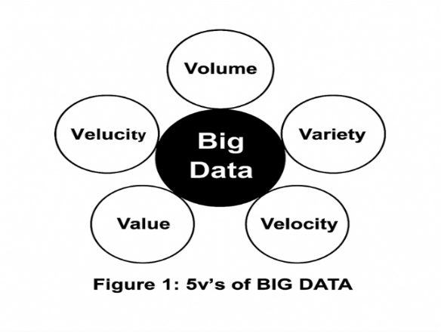
- Volume: Refers to the enormous amount of data generated every second from various sousuch as social media platforms, vehicles, financial institutions, and air travel.
- Velocity: Indicates the rapid speed at which data is created, processed, and analysed in real-time or near real-time.
- Variety: Encompasses diverse types of data including structured, unstructured, and semi-structured formats.
- Veracity: Pertains to the accuracy, trustworthiness, and quality of data, emphasizing the importance of validating data to ensure reliable analysis.
- Value: Represents the meaningful insights and benefits that can be extracted from the data.

Usually, big data follows these key steps:
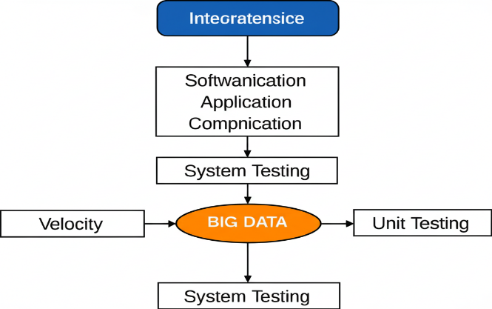
Fig: Big data flow

- Data classification
- Data collection
- Pattern identification
- Prediction generation
- Data visualization

1.1.1 ANALYSIS AND PREDICTION OF GOOGLE PLAYSTORE APPS
To analyse and forecast trends on the Google Play Store, you can look at factors such as app ratings, user reviews, download counts, and update frequency. Using machine learning models, it's possible to predict how apps might perform in the future based on past data. Keeping an eye on rising technologies or new app categories can also help identify future trends. With intense competition globally, it's important for developers to ensure they are moving in the right direction. To maintain their revenue and market position, app developers need strategies to stay relevant. The Google Play Store is currently the largest app marketplace. Although it generates more than twice the number of downloads compared to the Apple App Store, it earns only about half the revenue. As smart phones rapidly evolve, mobile applications have become essential in daily life. At present, there are around 0.675 million Android apps available on the Play Store, offering users a wide variety to choose from.

1.1.2 GOOGLE PLAYSTORE DATA
The Google Play Store is a digital distribution platform for Android applications. App data on the play store includes information like app name, developer details, version history, user reviews. and download statistics. Developers provide details such as app description, screenshots, and release notes. Users can access and update apps, and the play store uses algorithms to recommend relevant apps based on user preferences and behaviour. App data is crucial for users to make informed decisions and for developers to track and improve their app's performance.

1.1.3 MACHINE LEARNING
Apache Machine learning is defined as a Data Warehouse system built on top of Apache Hadoop for analysis and applying query on a large data set. It changes over SQL-like queries into Map Reduce for simple execution and preparing of amazingly substantial volumes of information. The three significant functionalities for which machine learning is conveyed are: data Summation, data Analysis and data query. The machine learning query language is known as the Machine Learning QL. In any case, machine learning QL does not offer help for online transaction processing and view emergence. It just offers sub-query support.

WHY MACHINE LEARNING?
Machine learning is growing in importance due to increasingly enormous volumes and variety of data, the access and affordability of computational power, and the availability of high-speed Internet.
These digital transformation factors make it possible for one to rapidly and automatically develop models that can quickly and accurately analyse extraordinarily large and complex data sets.
There are a multitude of use cases that machine learning can be applied to in order to cut costs, mitigate risks, and improve overall quality of life including recommending products/services, detecting cyber security breaches, and enabling self-driving cars. With greater access to data and computation power, machine learning is becoming more ubiquitous every day and will soon be integrated into many facets of human life.
Machine learning enables clients to all the while get to the information and expands the reaction time, for example the time framework or useful unit takes to respond to a given information.

1.1.4 HADOOP DISTRIBUTED FILE SYSTEM
For Hadoop Distributed File System. HDFS operates as a distributed file system designed to run on commodity hardware. HDFS is fault-tolerant and designed to be deployed on low-cost commodity hardware. HDFS provides high throughput data access to application data and is suitable for applications that have large data sets and enables streaming access to file system data in Apache Hadoop. So, what is Hadoop. And how does it vary from HDFS? A core difference between Hadoop and HDFS is that Hadoop is the open-source framework that can store, process and analyse data, while HDFS is the file system of Hadoop that provides access to data. This essentially means that HDFS is a module of Hadoop. As we can see, it focuses on Name Nodes and Data Nodes. The Name Node is the hardware that contains the GNU/Linux operating system and software. The Hadoop distributed file system acts as the master server and can manage the files, control a client's access to files, and overseas file operating processes such as renaming, opening, and closing files.
A Data Node is hardware having the GNU/Linux operating system and Data Node software. For every node in a HDFS cluster, you will locate a Data Node. These nodes help to control the data storage of their system as they can perform operations on the file systems if the client requests, and also create, replicate, and block files when the Name Node instructs.

1.1.5 DEEP LEARNING
Deep learning is a type of machine learning and artificial intelligence (AI) that imitates the way humans gain certain types of knowledge. Deep learning models can be taught to perform classification tasks and recognize patterns in photos, text, audio and other various data. It is also used to automate tasks that would normally need human intelligence, such as describing images or transcribing audio files.
A type of advanced machine learning algorithm, known as an artificial neural network (ANN), underpins most deep learning models. As a result, deep learning may sometimes be referred to as deep neural learning or deep neural network (DDN).
Deep learning is the subset of machine learning methods which are based on artificial neural networks with representation learning.
- Supervised learning (SL) is a paradigm in machine learning where input objects (for example, a vector of predictor variables) and a desired output value (also known as human-labelled supervisory signal) train a model. The training data is processed, building a function that maps new data on expected output values.
- Unsupervised learning: Weak supervision, also called semi-supervised learning, is a paradigm in machine learning, the relevance and notability of which increased with the advent of large language models due to large amount of data required to train them. It is characterized by using a combination of a small amount of human-labelled (exclusively used in more expensive and time-consuming supervised learning paradigm).
- Semi-supervised learning: Neural network tasks are often categorized as discriminate (recognition) or generative (imagination). Often but not always, discriminate tasks use supervised methods and generative tasks as unsupervised (see Venn diagram); however, the separation is very hazy. For example, object recognition Favors supervised learning but unsupervised learning can also cluster objects into groups. Furthermore, as progress marches onward some tasks employ both methods, and some tasks swing from one to another.

1.1.6 NEURAL NETWORKS
We can divide neural network in to different forms such as artificial neutral network, deep neutral network, recurrent neural network, convolution deep neutral networks. Each form has its own importance and its own features. In neutral network we have input layer, number of hidden layers, and output layer.

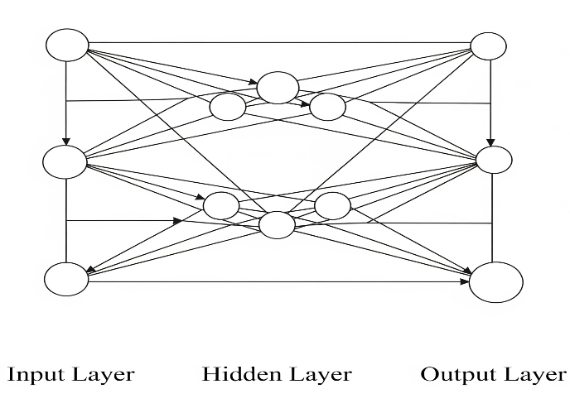
Fig: Layered approach of neural network
Input layer: represents dimensions of the input vector.
Hidden layer: represents the intermediary nodes that divide the input space into regions with (soft) boundaries. It takes in a set of weighted input and produces output through an activation function.
Output layer: represents the output of the neural network.

DEEP NEURAL NETWORK
A Deep Neural Network (DNN) is a machine learning technique that allows a computer, by training it, to do tasks that would be very difficult to do using conventional programming techniques Neural network algorithms were inspired by the human brain and its functions: like our human mind, it is designed to work not only by following a preset list of rules, but by predicting solutions and drawing conclusions based on previous iterations and experiences. Deep neural networks (DNNS) have achieved unprecedented success in computer vision. However, their superior performance comes at the considerable cost of computational complexity, which greatly hinders their applications in many resource-constrained devices, such as mobile phones and Internet of Things (IOT) devices. Therefore, methods and techniques that can link the efficiency bottleneck while preserving the high accuracy of DNNs are in great demand to enable numerous edge Al applications. This chapter provides an overview of efficient deep learning methods. We start from introducing popular model compression methods, including pruning, factorization, and quantization. We then describe compact model design techniques including efficient convolution layers and representative efficient CNN architectures. Finally, to reduce the large design cost of these manual solutions, we discuss the Auto MI. framework for each of them, such as neural architecture search (NAS) and automated pruning and quantization.
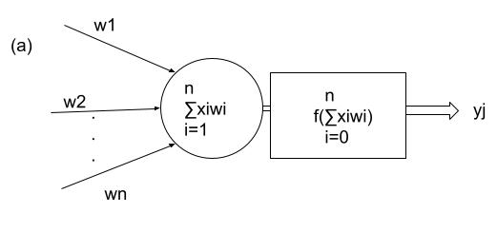
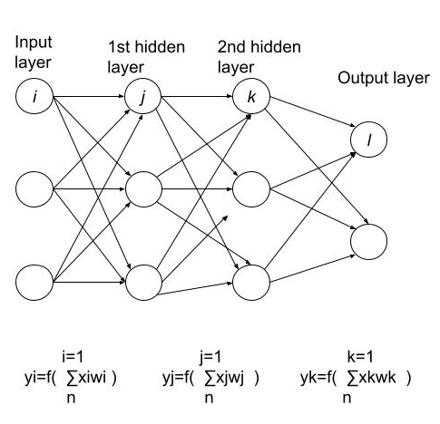
Fig: The building block of deep neural network

1.1.7 MACHINE LEARNING vs DEEP LEARNING
- This is a common question and if you have read this far, you probably know by now that it should not be asked in that way. Deep Learning algorithms are Machine Learning algorithms Therefore, it might be better to think about what makes Deep Learning special within the field of Machine Learning. The answer: the ANN algorithm structure, the lower need for human intervention, and the larger data requirements.
- First and foremost, while traditional Machine Learning algorithms have a rather simple structure, such as linear regression or a decision tree. Deep Learning is based on an artificial neural network. This multi-layered ANN is, like a human brain, complex and intertwined.
- Secondly, Deep Learning algorithms require much less human intervention. Remember the Tesla example? If the STOP sign image recognition was a more traditional machine learning algorithm, a software engineer would manually choose features and a classifier to sort images, check whether the output is as required, and adjust the algorithm if this is not the case. As a deep learning algorithm, however, the features are extracted automatically, and the algorithm learns from its own errors (see image below).

1.1.8 WHY DEEP LEARNING?
In traditional Machine learning techniques, most of the applied features need to be identified by a domain expert in order to reduce the complexity of the data and make patterns more visible to learning algorithms to work.
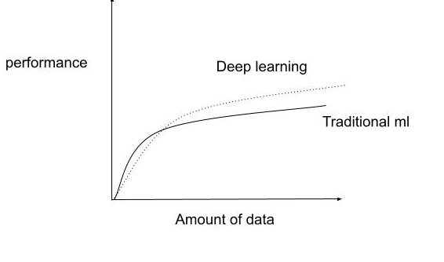
Graph1: Performance of deep learning
1.2 PROBLEM STATEMENT
In this project we have focused on our 2 objectives. We have taken the data set and observe it nicely and as per our need we have taken various attributes to analyse and further display the result. By doing this, we can clearly and easily observe the data set. Moreover, firstly, I will analyse different attributes given in data set. Secondly, I will do prediction of those different attributes like predict whether the user review is positive or negative.

1.3 OBJECTIVE
The main goal of this project is to analyse different attributes of given application like application name, category, rating, reviews, size, installs, type, price, content, rating, genres, last updated, current version, android version. And to find out the most rated and most reviewed apps and also to distinguish between the apps which are either free or paid using Machine learning technology
The second objective is to predict whether the user review for different application positive or negative using deep neural network in Deep Learning.

1.4 METHODOLOGY
The implementation of this project is divided in to 2 parts

1.4.1 ANALYSIS
In these various attributes like application name, category, rating, reviews, size, installs, type, price, content rating, genres, last updated, current version, android version are analysed using machine learning QL.
steps for implementing the analysis part:
- First, I have selected the data set
- Then that information is sent to HDFS
- Then in machine learning I have created a database
- In the above created database tables are created

1.4.2 PREDICTION
Since the English alphabetical data is converted to mathematical value. And now will be passed through the neural network for testing purposes. The data is passed through the neural network with some randomized weights on each link using feed forward process. Based on the weight model predict the value and based on these predictions the value is compared with the actual output. Error functions are calculated based on these predictions and actual values. Back propagation technique is used to adjust these weights by minimizing the error function. This error is minimized using stochastic gradient descent and after that new weight is adjusted. This step is performed several times keeping in mind that model doesn't over fit the given training data. After training process testing is done and based on this data set our accuracy factor is calculated. In this model we set the probabilistic values ie. if we get the actual output > 0.5 then review would be positive and if the output < 0.5 then the review would be negative otherwise neutral.
2. LITERATURE SURVEY

2. LITERATURE SURVEY
In the recent years, enormous work is carried out in the domain of Weather forecasting. Weather forecasting is one of the applications to predict state of climate in future at a given location.

2.1 Big Data Techniques for efficient storage and processing of weather
Big Data is mainly used to describe the exponential growth and availability of extremely large data sets that may be analysed computationally to reveal patterns, trends and associations. Applications of data analysis arise in many fields perhaps most importantly in Weather Forecasting. Weather Forecasting is one of the applications of Science and Technology to predict the state of atmosphere for upcoming time at a given location. Now-a-days as size of the weather data is increasing tremendously, Weather Forecasting seems to be built on Big Data analytic. The accuracy of Weather Forecasting plays a vital role in daily routine of Business and their decisions. For accurate weather prediction, there is a need to store and process huge amounts of weather data. In general, a framework Apache Hadoop is most popularly used for storing and processing of large data sets. In this study. Spark and Cassandra Integration is experimented to evaluate the time taken to store and process large data sets for further processing. And the result is evaluated with Hadoop Map Reduce.

METHODOLOGY USED IN THIS RESEARCH PAPER: -
Hadoop map reduce implementation: Hadoop Map Reduce is a software framework for easily writing applications which process vast amounts of data (multi-terabyte data-sets) in-parallel on large clusters (thousands of nodes) of commodity hardware in a reliable, fault-tolerant manner. A Map Reduce job usually splits the input data-set into independent chunks which are processed by the map tasks in a completely parallel manner. The framework sorts the outputs of the maps, which are then input to the reduce tasks. Typically, both the input and the output of the job are stored in a file-system. The framework takes care of scheduling tasks, monitoring them and re-executes the failed tasks.
Spark implementation: -when referring in to "spark implementation" in the literature survey.
It typically means examining and analyzing existing research, publications, and academic works that discuss the implementation, optimization, and application of Apache spark, a distributed computing frame work.
No SQL Database Cassandra: - No SQL Database Cassandra provides a provision for storage and retrieval of unstructured data unlike the traditional data base which use tabular relations. No SQL. Data base is being efficiently used for real time web application and high speed online transactional data.

2.2 COMMERCIAL PRODUCT ANALYSIS USING HADOOP MAP REDUCE
It examines how an association can find certified open entryways in solidifying disengaged and online data to give cleverness on how consolidating separated and online data can be helpful. Associations use proposition estimations which have the above favourable circumstances. Proposition computations are best seen for their use on online business web destinations. Here they use customer's interests as a commitment to make a record to make a record of endorsed things.
The first one is called content-based sifting. Content based separating can moreover be called an intellectual sifting, which endorses things dependent on a examination between the substance of the things and a customer profile.
Additionally, the next one is community-oriented sifting. It relies on not just the attributes of the things yet rather how persons for example various customers respond to comparable articles. Affiliations need to get all of the data characteristics, detached on the web, in to a lone database, which would be moreover refined by front line examination procedures, and use the solidified data for exactness concentrating on.

2.3 REVIEW PAPER ON HADOOP AND MAP REDUCE
Big Data is a data whose scale, decent variety, and intricacy require new engineering, methods, calculations, and investigation to oversee it and concentrate esteem and concealed leaming from it. Hadoop is the centre stage for organizing Big Data, and takes care of the issue of making it valuable for investigation purposes. Hadoop is an open-source programming venture that empowers the appropriated handling of vast data sets crosswise over bunches of item servers. It is intended to scale up from a single server to thousands of machines, with a high level of adaptation to internal failure. Since the big data is included principally with the overwhelming or gigantic measure of data, the speed to deal with the tremendous measure of data comes in to the photo.
Hadoop Map Reduce programming worldview and HDFS are progressively being utilized for processing vast and unstructured data sets. Hadoop empowers collaborating with the Map Reduce programming model while concealing the intricacy of conveying, arranging and running the product components in the general population or private cloud. Hadoop empowers clients to make cluster of item servers. Map Reduce has been displayed as a free platform-benefit layer appropriate for various necessity by cloud suppliers. It additionally empowers clients to comprehend the data processing and investigating.

2.4 SENTIMENT ANALYSIS OF TWITTER DATA WITHIN BIG DATA DISTRIBUTED ENVIRONMENT FOR STOCK PREDICTION
This paper covers design, implementation and evaluation of a system that may be used to predict future stock prices basing on analysis of data from social media services. The authors took advantage of large datasets available from Twitter micro blogging platform and widely available stock market records. Data was collected during three months and processed for further analysis. Machine learning was employed to conduct sentiment classification of data coming from social networks in order to estimate future stock prices. Calculations were performed in distributed environment according to Map Reduce programming model.
View huge amounts of information as sorted and the reality they are composed content; the Navie Bayes calculation was chosen for its quick procedure of preparing even with huge amount of preparing information and the way that it very well may be expanded. Considering huge amounts of information additionally result choice to execute the guide diminish rendition of Navie Bayes calculation.

2.5 PYTHON-- THE FASTEST GROWING PROGRAMMING LANGUAGE
Python has rapidly become the fastest-growing language in recent years. Its simplicity, readability, and versatility have contributed to its widespread adoption across various domains.
Python's extensive standard library and thriving ecosystem of third-party packages make it a go-to choose for web development, data science, artificial intelligence and more.
Various activities have been recorded in python and it has been used in iRobot Google, and Intel, etc.
2.6 MACHINE LEARNING ALGORITHMS: A REVIEW
Machine learning algorithms are computational models that enable systems to learn pattern from data and make predictions or decisions without explicit programming. These algorithms form the core of machine learning, a subset of artificial intelligence.
These are various types of machines learning algorithms, including supervised learning and unsupervised learning.
The selection of a specific algorithm depends on the nature of the problem, the type of data available, and the desired outcomes. As technology advances, researches continually develop new algorithms, contributing to the ever-evolving landscape of machine learning.

2.7 AN OVERVIEW OF DEEP LEARNING
Deep learning is an essential method of machine learning. Deep learning is rapidly suitable for the most sophisticated stage of a technology, prominent to enriched performance in numerous medical applications. The latest growth in machine learning, specifically with respect to deep learning. aids in recognition, classification, and computation of patterns in medical images. The main aim of these improvements is the ability to derive feature representation from learned data rather than designing those features by hand from domain-specific knowledge. In deep learning, the bottom-level network represents a low-level feature representation while the top-level network represents the output feature information. The computation of a deep learning network is faster with cheap hard ware.

2.8 THE POWER OF MOBILE APPLICATIONS
Mobile app development is rapidly growing. From retail, telecommunications and e-commerce to insurance, healthcare and government, organizations across industries must meet user expectations for real-time, convenient ways to conduct transactions and access information. Today, mobile devices and the mobile applications that unlock their value-are the most popular way for people and businesses to connect to the internet
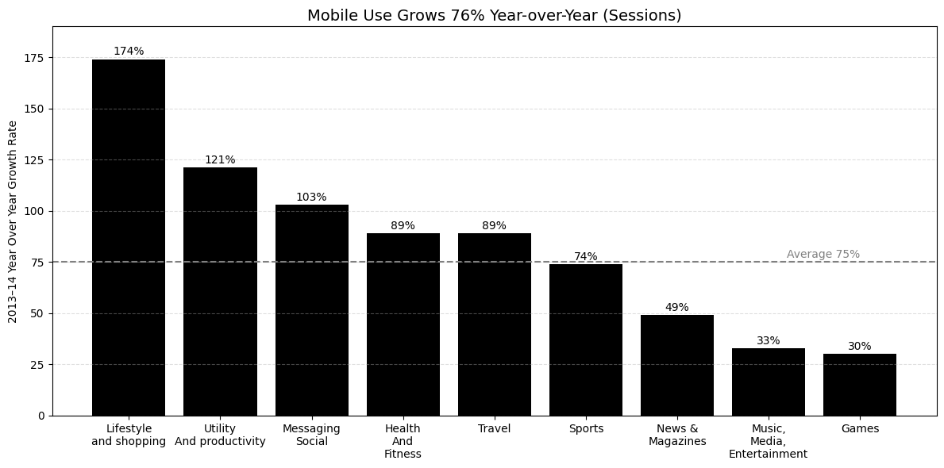
Graph2 : Mobile use grows year-over-year

In addition, late insights uncover that versatile media use overwhelms most of absolute media utilization. Kleiner Perkins Caufield and Bayer's report (2015) demonstrates that time spent by clients on versatile advanced media is the most astounding contrasted with others.
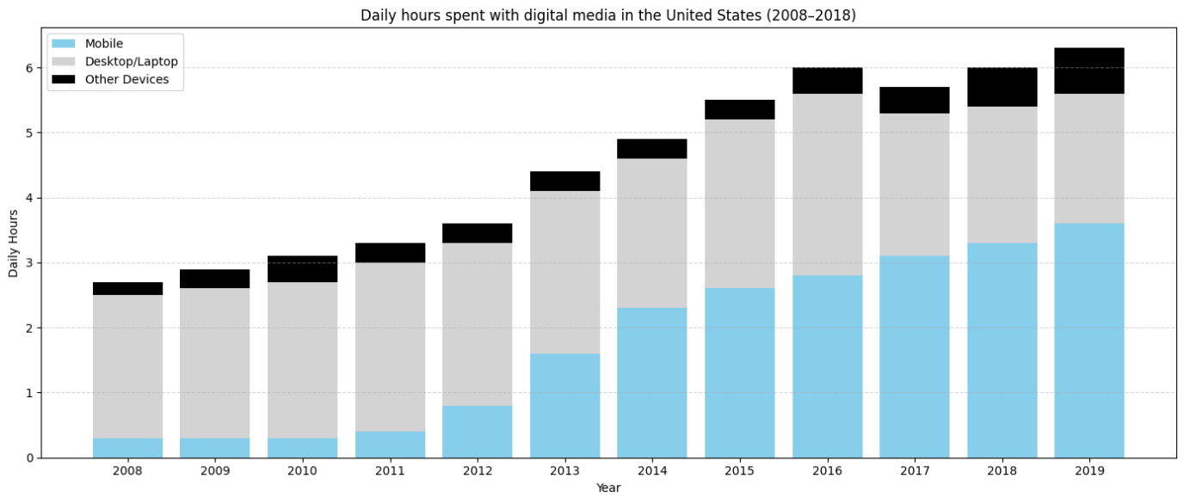
Graph3: Time spent per day with digital media

The number of apps available continues to grow rapidly across various platforms, providing users with a diverse range of tools, entertainment, and services. App stores, such as Google Play and the Apple app store, boast millions of applications, reflecting the dynamic landscape of technology and the ever-expanding needs of users.

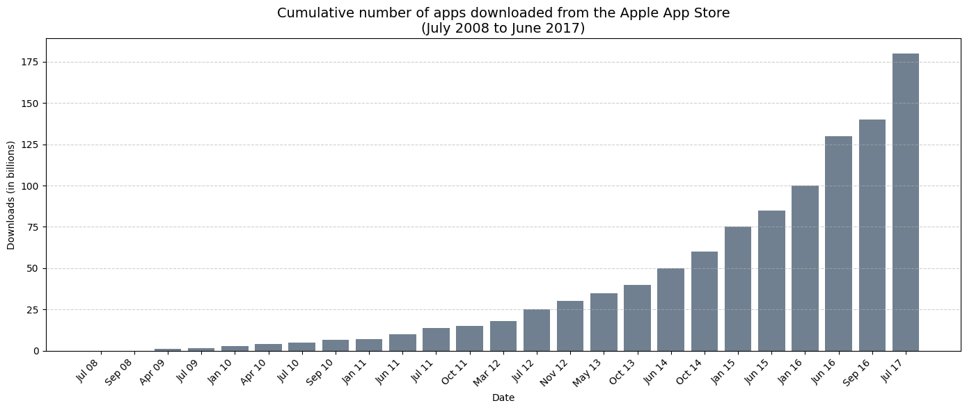
Graph 4: Number Of Apps Downloaded

Increment in the fame of versatile condition makes the field focused for individual engineers, organizations and merchants, since engineers need to get portable segment, the quantity of applications in stores increments and make the challenge increasingly extreme. The quantity of accessible applications for July 2008 to June 2017in the Graph4.
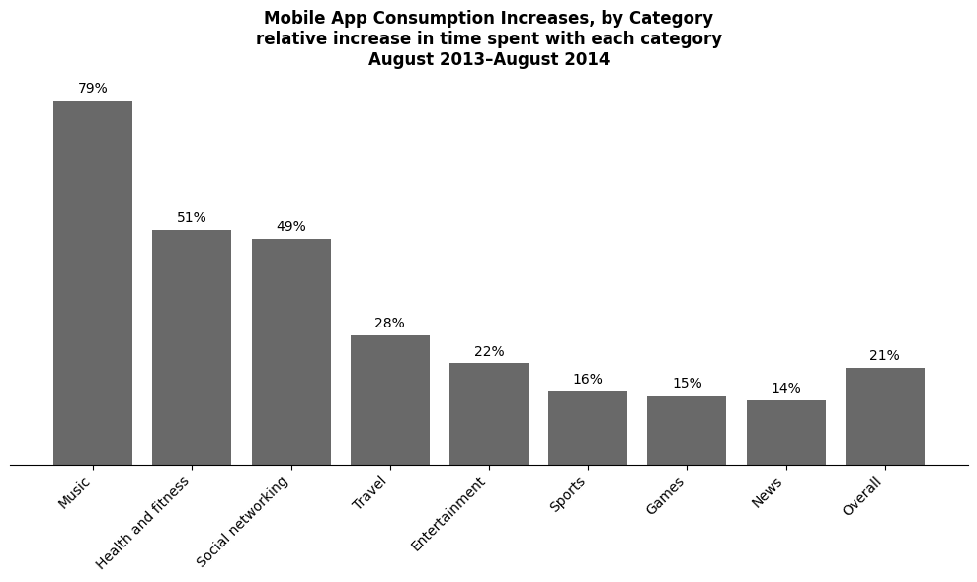Graph5: Relative Increase in Time Spent on Mobile App Categories
2.9 Mobile App Analytics
Mobile app analytics is a crucial aspect of app development, involving the systematic tracking and interpretation of user interactions within a mobile application. Through metrics like user engagement, retention, conversion rates, and in-app behaviour, developers gain valuable insights in to user preferences and app performance. These analytics empower developers to make data-driven decisions, refine features, optimize user experience, and ultimately enhance the overall success and sustainability of their mobile apps.
Furthermore, mobile app analytics plays a pivotal role in measuring the effectiveness of marketing campaigns, helping developers identify successful acquisition channels and user acquisition costs. Real-time data and user feedback contribute to agile development, allowing developers to quickly respond to user needs and market trends.
The iterative nature of app improvement driven by analytics fosters a dynamic development cycle, ensuring that mobile app remain relevant and competitive in a rapidly evolving landscape.
3. SYSTEM DEVELOPMENT

3.1 DESIGNING
DATA MODELS
A data model is a conceptual representation of how data is organized, stored, and accessed within a system or database. It defines the structure, relationships, constraints and rules governing the data to ensure consistency and integrity. Data models can be visualized through diagrams, such as entity-relationship diagrams for relational databases, providing a blueprint for designing and implementing databases. The choice of data model depends on the specific requirements of the application or system, guiding how data is manipulated and retrieved for efficient and meaningful use
TABLES
In the context of machine learning, the term "tables" typically refers to datasets or data tables. These tables are structured collections of data used for training and e valuating machine learning models. Each row in the table corresponds to an example or data point, and each column represents a feature of attribute.
For managed table, the following syntax is used: the syntax for managing tables in SQL can vary depending on the specific actions you vary depending on the specific actions you want to perform.

Here are some common table management operations:
1.Alter Table:
Add a new column:
Alter table your_table_name
ADD COLUMN new_column_name datatype;
1.Modify column data type:
ALTER TABLE your_table_name
MODIFY COLUMN existing_column_name
new_data_type;
2. Rename Table:
3. ALTER TABLE old_table_name
RENAME TO new_able_name;
4. Drop Table:
DROP TABLE your_table_name;
4.Truncate table (remove all rows, but keep the structure):
TRUNCATE TABLE your_table_name;
5. Backup Table (Using SELECT INTO):
SELECT
INTO new_backup_table
FROM your_table_name;

(I) DEEP NEURAL NETWORK MODELS
Neural networks are machine learning algorithms inspired by the structure and function of the human brain. They are composed of layers of interconnected "neurons", that process and transmit information.
Neural networks are commonly used for image classification, language translation, and speech recognition tasks. They are particularly powerful for handling complex, nonlinear relationships in data.
Training a neural network involves adjusting the weights and biases of the connections between neurons to minimize a loss function that measures the difference between the predicted output of the network and the true output.

Designing of DNN model for my project as:
1. Set the position of each word in to an array.
2.Make the different layers i.e. one input layer, one hidden layer, one output layer for neural network.
3.Send the randomized weight to each layer.
4.Add Sigmoid function to calculate and comparing it with actual output and then calculate the error. Based on this error weights are adjusted using Back Propagation.

3.2 ARCHITECTURE
3.2.1 MACHINE LEARNING ARCHITECTURE
Machine Learning architecture is defined as the subject that has evolved from the concept of fantasy to the proof of reality. As earlier machine learning approach for pattern recognitions has lead foundation for the upcoming major artificial intelligence program. Based upon the different algorithm that is used on the training data machine learning architecture is categorized into three types i.e. Supervised Learning. Unsupervised Learning, and Reinforcement Learning and the process involved in this architecture are Data Acquisition, Data Processing, Model Engineering, Excursion, and Deployment

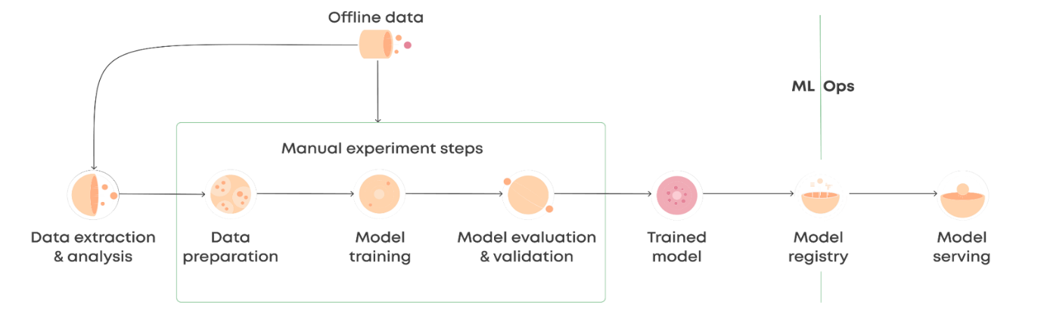
Fig: Machine Learning Pipeline
1. Data Acquisition
As machine learning is based on available data for the system to make a decision hence the first step defined in the architecture is data acquisition. This involves data collection, preparing and segregating the case scenarios based on certain features involved with the decision-making cycle and forwarding the data to the processing unit for carrying out further categorization. This stage is sometimes called the data preprocessing stage. The data model expects reliable, fast and elastic data which may be discrete or continuous in nature. The data is then passed into stream processing systems (for continuous data) and stored in batch data warehouses (for discrete data) before being passed on to data modelling or processing stages.
2. Data Processing
The received data in the data acquisition layer is then sent forward to the data processing layer where it is subjected to advanced integration and processing and involves normalization of the data, data cleaning, transformation, and encoding. The data processing is also dependent on the type of learning being used. For e.g., if supervised learning is being used the data shall be needed to be segregated into multiple steps of sample data required for training of the system and the data thus created is called training sample data or simply training data. Also, the data processing is dependent upon the kind of processing required and may involve choices ranging from action upon continuous data which will involve the use of specific function-based architecture, for example, lambda architecture, also it might involve action upon discrete data which may require memory-bound processing. The data processing layer defines if the memory processing shall be done to data in transit or in rest.
3. Data Modelling
This layer of the architecture involves the selection of different algorithms that might adapt the system to address the problem for which the learning is being devised, these algorithms are being evolved or being inherited from a set of libraries. The algorithms are used to model the data accordingly; this makes the system ready for the execution step.
4. Execution
This stage in machine learning is where the experimentation is done, testing is involved and tunings are performed. The general goal behind being to optimize the algorithm in order to extract the required machine outcome and maximize the system performance, The output of the step is a refined solution capable of providing the required data for the machine to make decisions.
5. Deployment
Like any other software output, ML outputs need to be operationalized or be forwarded for further exploratory processing. The output can be considered as a non-deterministic query which needs to be further deployed into the decision-making system.
It is advised to seamlessly move the ML output directly to production where it will enable the machine to directly make decisions based on the output and reduce the dependency on the further exploratory steps.
3.2.2 HDFS ARCHITECTURE
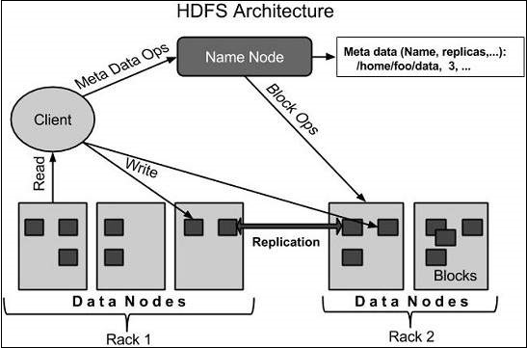
Fig: HDFS architecture

The Hadoop Distributed File System (HDFS) is the underlying file system of a Hadoop cluster. It provides scalable, fault-tolerant, rack-aware data storage designed to be deployed on commodity hardware. Several attributes set HDFS apart from other distributed file systems. Among them, some of the key differentiates are that HDFS is:
- designed with hardware failure in mind
- built for large datasets, with a default block size of 128 MB
- 20
- optimized for sequential operations
- rack-aware
- cross-platform and supports heterogeneous clusters

Data in a Hadoop cluster is broken down into smaller units (called blocks) and distributed throughout the cluster. Each block is duplicated twice (for a total of three copies), with the two replicas stored on two nodes in a rack somewhere else in the cluster. Since the data has a default replication factor of three, it is highly available and fault-tolerant. If a copy is lost (because of machine failure, for example), HDFS will automatically re-replicate it elsewhere in the cluster, ensuring that the threefold replication factor is maintained.
HDFS architecture can vary, depending on the Hadoop version and features needed:
- Vanilla HDFS
- High-availability HDFS
HDFS is based on leader/follower architecture. Each cluster is typically composed of a single Name Node, an optional Secondary Name Node (for data recovery in the event of failure), and an arbitrary number of Data Nodes.

3.3 DATA FLOW
3.3.1 DATAFLOW IN MACHINE LEARNING
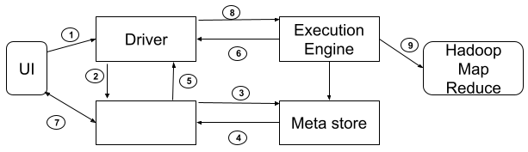
Fig: Flow of data in machine learning

3.3.2 DATA FLOW IN DEEP NEURAL NETWORK
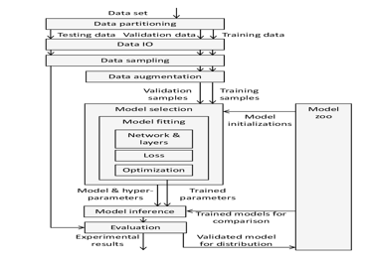
Fig: Data-flow in Deep Neural Network
Steps in flowchart:
1. Firstly, the data set is imported from the web and divided in to training and testing
2. Assigning the position of each word from the data set in an array because our data set is in text form so we cannot directly pass this data set in to our model
3. Now, set the positive review to 1 and negative review to 0.
4. Break the data into two forms i.e. training and testing for accuracy purpose
5. Train the model according to the features/attributes of training data set
6. Pass the testing data set in to testing model and calculate the accuracy.
7. Now, pass your own data set for calculating the output and check the accuracy.

3.4 REQUIREMENTS
3.4.1 HARDWARE REQUIREMENTS
Types of hardware | Hardware used
Gaming PC | High-end CPU (eg, Intel Core i7 or AMD Ryzen 7)
Smartphone | System-on-chip(soc) with integrated CPU and GP
Hardware | Quad core Intel it has 4GB RAM
Memory | 4GB (2.4 GB on virtual machine)

3.4.2 SOFTWARE REQUIREMENTS:
Type of software | versions
Operating system | Linux, Windows
Python Jupyter | 4.3.0
Hadoop | 2.7.3
Web browser | Mozilla Firefox 28.
Eclipse IDE | 4.8

3.4.3 ADVANTAGES OF VMWARE WORKSTATION:
- it can develop various software under many frameworks.
- It can import and modify virtual machines.
- Ability to clone virtual machines frameworks.
- Turn your own machine into a virtual machine framework.

3.5 TEST PLAN
3.5.1 DATASET
A data set is a structured collection of data organized in a tabular format, typically with rows representing individual instances or observations and columns representing attributes or features of those instances.it is a fundamental component in data science, machine learning, and statistical analysis. A data set is organized into some type of data structure. In a database, for example, a data set might contain a collection of business data (names, salaries, contact information, sales figures, and so forth). The database itself can be considered a data set, as can bodies of data within it related to a particular type of information, such as sales data for a particular corporate department. The term data set originated with IBM, where its meaning was similar to that of file. In an IBM mainframe operating system, a data sets a named collection of data that contains individual data units organized (formatted) in a specific, IBM-prescribed way and accessed by a specific access method based on the data set organization. Types of data set organization include sequential, relative sequential, indexed sequential, and partitioned. Access methods include the Virtual Sequential Access Method (VSAM) and the Indexed Sequential Access Method (ISAM).

(1) google play store. CSV
This data set is for web scratched information of 10k play store application for examining the android advertises. This is the offline dataset which can be utilized by a client to have the android market of different utilization of various classes music, camera etc. with the assistance of this, client can foresee whether any given application will get lower or higher rating level, which app is free or which is paid, about hit reviews, about the latest version of the particular app and many more things to analyse. This dataset can be additionally utilized for further references for the suggestion of any application. In addition, this offline dataset is chosen in order to decide the forecast precisely as online information gets refreshed all around much of the time, likewise, to monitor its old clients to comprehend their inclinations better.
Sample record from the offline-dataset (google play store.csv) is shown in the following table:
App | Category | Rating | Reviews | Size | Installs | Type | Price | Content Rating | Genres | Last Updated | Current Ver | Android Ver
Photo Editor & Candy Camera & Grid & Scrapbook | ART_  AND_  DESIGN | 4.1 | 159 | 19M | 10,000+ | Free | 0 | Everyone | Art &  Design | January 7, 2018 | 1.0.0 | 4.0.3 and up
Colouring book moana | ART_AND_DESIGN | 3.9 | 967 | 14M | 500,000+ | Free | 0 | Everyone | Art & Design; Pretend Play | January 15, 2018 | 2.0.0 | 4.0.3 and up
U Launcher Lite – FREE Live Cool Themes, Hide … | ART_AND_DESIGN | 4.7 | 87510 | 8.7M | 5,000,000+ | Free | 0 | Everyone | Art & Design | August 1, 2018 | 1.2.4 | 4.0.3 and up
Sketch – Draw & Paint | ART_AND_DESIGN | 4.5 | 215644 | 25M | 50,000,000+ | Free | 0 | Teen | Art & Design | June 8, 2018 | Varies with device | 4.2 and up
Pixel Draw – Number Art colouring Book | ART_AND_DESIGN | 4.3 | 9672 | 2.8M | 100,000+ | Free | 0 | Everyone | Art & Design; Creativity | June 20, 2018 | 1.1 | 4.4 and up

Table1: Data set columns and its specification
(2) Google play store_user_reviews.csv
Google play store_user_reviews.csv" likely refers to a CSV (Comma-Separated Values) file that contains data related to user reviews on the Google Play Store. In this context, the file could include structured information about the reviews that users have submitted for various apps available on the Google Play Store.
Column Name | Data Type | Description
App ID | String or Numeric | Unique identifier for the application being reviewed.
User ID | String or Numeric | Unique identifier for the user who wrote the review.
Review Text | Text | The content of the user's review.
Rating | Numeric | The numerical or star rating given by the user.
Date_Posted | Timestamp | The date and time when the review was posted.
Likes_Up-votes | Numeric | The count of users who found the review helpful.
Developer_Response | Text or Boolean | Indicates whether the app developer responded to the review.
Version | String | The version of the app at the time of the review.
Language | String | The language in which the review was written.
Device_Info | String | Details about the device used by the reviewer.
Table 2: Dataset columns and its specifications
Record from the downloaded-dataset (google play store user reviews.csv) is shown in the following table:
App_ID | App_Name | Category | Rating | Reviews
com.example | Example App | Productivity | 4.5 | 5000

3.6 ALGORITHMS
3.6.1 ALGORITHM USED FOR PREDICTION PART
Algorithm analysis
1) Before learning algorithm analysis
  - Learn to solve problems by “computational thinking”
  - Data Structures
2) After learning algorithm analysis
  - How efficient is my first solution?
  - How to improve
3.6.2 MAP REDUCE ALGORITHM
A Map Reduce is a data processing tool which is used to process the data paralleled in a distributed form. It was developed in 2004, on the basis of paper titled as "Map Reduce: Simplified Data Processing on Large Clusters," published by Google.
The Map Reduce is a paradigm which has two phases, the mapper phase, and the reducer phase. In the Mapper, the input is given in the form of a key-value pair. The output of Mapper is fed to the reducer as input. The reducer runs only after the Mapper is over.
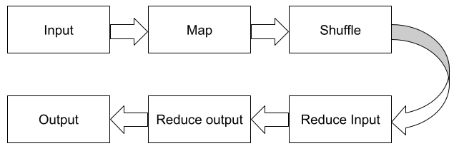
Fig: MapReduce Flow

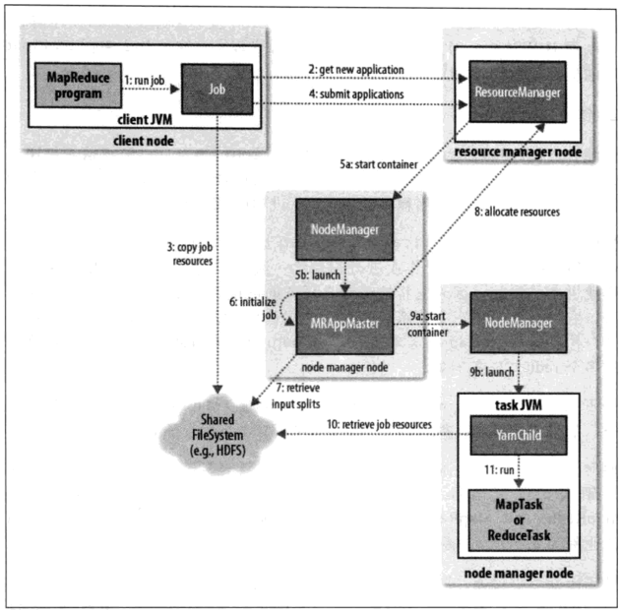Fig: Hadoop YARN Application Flow for a MapReduce Job

3.6.3 ALGORITHM USED FOR PREDICTION PART
For prediction, a supervised machine learning algorithm like Linear Regression or Random Forest is used. The model is trained on historical data to learn patterns and make future forecasts.
Steps:
- Data collection and cleaning
- Feature selection
- Model training
- Evaluation using metrics like MAE or RMSE
- Final prediction
This algorithm is chosen for its accuracy, efficiency, and ability to handle large datasets.

3.6.4 ВАСKPROPAGATION:
Back propagation is a process involved in training a neural network. It involves taking the error rate of a forward propagation and feeding this loss backward through the neural network layers to fine-tune the weights. Back propagation is the essence of neural net training. Back propagation, short for "backward propagation of errors," is a supervised learning algorithm used for training artificial neural networks. It is a crucial component in optimizing the weights of the network to minimize the difference between the predicted output and the actual target values.
Here's a brief explanation of the back propagation algorithm:
Forward Pass:
The input data is fed into the neural network, and the activations of each neuron are calculated layer by layer through the network until the output is generated.
These activations are the results of applying weights to the input data and passing them through activation functions.
Calculate Error:
The output of the neural network is compared to the actual target values to calculate the error. This error represents the difference between the predicted and actual outcomes.
Backward Pass:
The error is then propagated backward through the network. For each weight in the network, the algorithm calculates the gradient of the error with respect to that weight. This gradient indicates how much the error would increase or decrease if the weight is adjusted.
Weight Update:
The weights are then updated in the opposite direction of the gradient to reduce the error. The learning rate, a hyper parameter, controls the size of the step taken during the weight update to prevent overshooting the optimal weights.
Iterative Process:
Steps 1 to 4 are repeated iteratively for multiple epochs or until a convergence criterion is met. The process of forward pass, error calculation, backward pass, and weight update continues until the neural network learns to make accurate predictions.
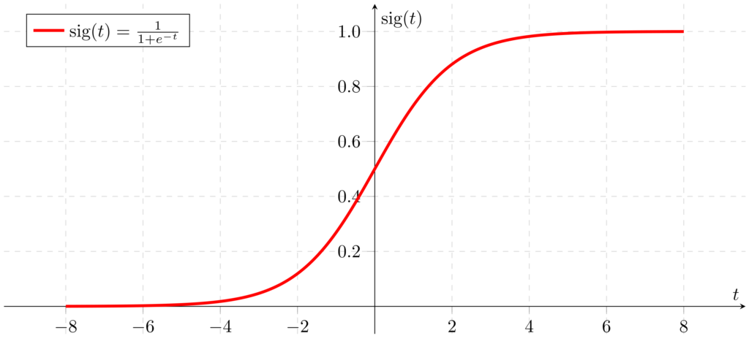
Graph6: Sigmoid function
The Sigmoid function is often used in the context of machine learning and neural networks If you're looking for an app related to machine learning, data analysis, or a specific domain where Sigmoid functions are applicable, you might find relevant applications in those categories on the app store. Always be cautious and ensure that the apps you download are from reputable developers and have good user reviews to ensure the quality =and security of the application.

3.6.5 FEED FORWARD:
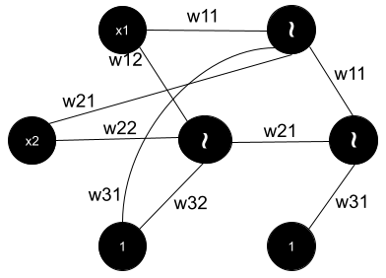
Fig: Feedforward Neural Network with Weights
Feed forward is a term used in the context of artificial neural networks, and it refers to the process in which information travels through the network in one direction from the input layer to the output layer-without any feedback loops. In a feed forward neural network, the flow of information is unidirectional, and there are no connections that create cycles or loops within the network.
Here's a step-by-step overview of the feed forward algorithm in the context of a basic neural network:
Input Layer:
The process begins with an input layer, where each neuron represents a feature or input variable
Weighted Sum:
Each connection (synapse) between neurons in one layer and the neurons in the next layer is associated with a weight. The input values are multiplied by these weights, and the results are summed for each neuron in the next layer
Weighted Sum=?=1?(Input?Weight?)+Bia weighted sum=i=ln(InputWeight)+Bias
The bias term is an additional parameter added to the weighted sum.

Activation Function:
The weighted sum is passed through an activation function, Common activation functions include the sigmoid function, hyperbolic tangent (tanh), or rectified linear unit (ReLU)
Activation-(Weighted Sum) Activation-f (Weighted Sum)
Propagation:
The output of the activation function becomes the input for the next layer. This process is repeated for each layer in the neural network, from the input layer to hidden layers and finally to the output layer.
Output Layer:
The final layer produces the network's output, which is the result of the input data being transformed as it passes through the network.
The weights and biases in the network are initially set randomly and are then adjusted during the training phase using algorithms like back propagation. Back propagation involves computing the gradient of the error with respect to the weights and updating the weights to minimize the error. The feed forward algorithm is foundational in the field of neural networks and is a key component in training models for various machine learning tasks.

IMPLEMENTATION
There are six modules in the project are:
1. Descriptive Analysis
2. Exploratory Data Analysis
3. Data preprocessing and visualization
4. Features Engineering
5.Model building and Evaluation
6.Model Development

1) Descriptive Analysis
Descriptive analysis is a statistical method used to summarize and describe the main features of a dataset. The goal is to provide a clear and concise overview of the key characteristics and patterns within the data, helping to understand its central tendencies, variability, and distribution. This type of analysis is typically the first step in the data analysis process and is essential for gaining insights into the nature of the data.

2) Exploratory Data Analysis:
Exploratory Data Analysis (EDA) is an approach to analysing data sets with the primary goal of summarizing their main characteristics, often with the aid of graphical representations. Developed by statistician John Tukey, EDA is used to uncover patterns, relationships, anomalies, and trends within the data, providing a foundation for more in-depth analysis. Exploratory Data Analysis is widely used in various fields, including statistics, data science, and machine learning. It serves as a crucial step in the data analysis process, helping analysts form hypotheses, make informed decisions about subsequent analyses, and gain a deeper understanding of the data at hand.
3) Data Pre-processing and Visualization:
Data visualization is the representation of data in graphical or visual formats. It is a powerful tool for gaining insights from data, identifying patterns, and communicating findings effectively. Visualization techniques help to make complex datasets more understandable and can reveal trends, outliers, and relationships between variables. Common types of data visualizations include.
For the Pre-processed data, we identify the top columns which have the greatest influence on the purchase amount
4) Feature Engineering:
Feature engineering is a crucial process in data science and machine learning that involves creating new features or transforming existing ones to improve the performance of a predictive model. The goal of feature engineering is to enhance the representation of the data, making it more suitable for the specific task at hand. Well-engineered features can significantly impact the success of a machine learning model.
5) Model building and Evaluation:
Model building is a systematic process in machine leaming that involves creating a predictive model to make informed predictions or decisions based on data. The model development occurred in three steps. (A) Step I was used to evaluate the process for selecting a single model for validation on an independent test set based on training and test set definitions in Field-in. (2007). The model strategy was successful in selecting a single model with a similar AUC estimate to that previously published (see Supplementary Results). (B) The model from step I was promising but under powered. As a result, all Iconic samples were used for training in step 2 to select a single top model to classify compounds in step 3. The strategy for model building and selection was identical to that implemented in step 1 with the qualification that the performance of the top model is not preferentially driven by correctly classifying training samples defined in the process evaluation (step 1). (C) Step 3 is the validation of the top qPCR-based model from step 2 on an independent test set. The independent test set is composed of samples from multiple sites using different protocols.
6) Model Deployment:
The best-fit model among all the 5 model is deployed to the user interface. The user will be to enter the numerical and categorical values to predict purchase amount. The predictorshould able to validate data if it is within the given range and display the purchase amount.

4. ALGORITHMS

4.ALGORITHMS:
List of algorithms used in implementation of our experiment are:
- Support Vector Machine
- k-nearest algorithm
- Artificial Neural Network
- Random forest algorithm
- logistic Regression algorithm

4.1 SUPPORT VECTOR MACHINE:
Pseudocode:
Importing the necessary packages Examples: import pandas as padded SVM
Step 1: START.
Step 2: Reading the dataset.pd.read.esv (file name) #reads the dataset file.
Step 3. Data cleaning and preprocessing of data Resampling the data as normal and fraud class ie. Normal and fraud under under sampling of data is done. Data is scaled (if any value then eliminated) and normalized. Dataset is splitted into two set as train data and test data using split () on training data is used to split the data.
Step 4: Training the data using the SVM algorithm SVM classifier is called as classifier. Predict () #which predicts whether transaction fraud or non-fraud.
Step 5: Calculating the fraud transactions and valid transactions, then calculating the recall, precision and accuracy and stored in the respective locations.
Step 6: STOP.
4.2 K-NEAREST NEIGHBOUR
Pseudocode:
Step 1: START
Step 2: Loading of dataset pd read. csviesv file) reads the csv file and loads
Step 3: cleaning and normalization of data
Normal=0
Fraud=1#resampling data is scaled and normalized
Train_test_split () #splitting of dataset into train and test data
Step 4: Train the model then fit the trained model
Trained the data using Knn classifier
K Neighbours Classifier () Knn classifier which does classification of transactions
Step 5: Calculating the number of frauds, valid transactions and recall, precision and accuracy calculated.
Step 6: STOP

4.3 ARTIFICIAL NEURAL NETWORKS(ANN):
Pseudocode:
The ANN algorithm has two parts: Training part and testing part
Training part: Def ANN
Step 1: START
Step 2: loading and observing the dataset
Pd read.csv (. csvyfreads the dataset
resampling of data
Standard Scale () #scaling and normalization of data
Step 3: Data prepossessing
Train_test_split () #splitting of data
Step 4: Training the model
Dense () #Adding data to activation function
Step 5: Analyzing the model
prediction of fraud is made and this framed data is stored it can used to test training the model takes longer time so it is stored
Step 6: STOP
Testing part:
Def ANN is carried out in a similar way; the only difference is that the stored trained model is used to test the data and classify it.
4.4 RANDOM FOREST TREE ALGORITHM:
Random Forest is a widely used classification and regression algorithm. As classification and regression are the most significant aspects of machine learning, we can say that the Random Forest Algorithm is one of the most important algorithms in machine learning. The capacity to correctly classify observations is helpful for various business applications, such as predicting whether, a specific user would buy a product or a loan will default or not. Classification algorithms in data science include logistic regression, support vector machines, naive Bayes classifiers, and decision trees. On the other hand, the random forest classifier is near the top of the classifier hierarchy. This article will deep dive into how a Random Forest classifier works with real-life examples and why the Random Forest is the most effective classification algorithm. Let's start with a basic definition of the Random Forest Algorithm. The Random Forest Algorithm is composed of different decision trees. each with the same nodes, but using different data that leads to different leaves. It merges the decisions of multiple decision trees in order to find an answer, which represents the average of all these decision trees. The random forest algorithm is a supervised learning model; it uses labelled data to "learn how to classify unlabelled data. This is the opposite of the K-means Cluster algorithm, which we learned in a past article was an unsupervised learning model. The Random Forest Algorithm is used to solve both regression and classification problems, making it a diverse model that is widely used by engineers.

4.5 LOGISTIC REGRESSION ALGORITHM
Logistic Regression is one of the most used Machine Learning algorithms for binary classification. It is a simple algorithm that you can use as a performance baseline, it is easy to implement and it will do well enough in many tasks. Therefore, every Machine Learning engineer should be familiar with its concepts. The building block concepts of Logistic Regression can also be helpful in deep learning while building neural networks. In this post, you will learn what Logistic Regression is, how it works, what are advantages and disadvantages and much more. These probabilities must then be transformed into binary values in order to actually make a prediction. This is the task of the logistic function, also called the sigmoid function. The Sigmoid-Function is an S-shaped curve that can take any real-valued number and map it into a value between the range of 0 and 1, but never exactly at those limits. This values between 0 and I will then be transformed into either 0 or 1 using a threshold classifier

UMLS
UML SOFTWARE DESIGN
UML, short for Unified Modelling Language, is a standardized modelling language consisting of an integrated set of diagrams, developed to help system and software developers for specifying. visualizing, constructing, and documenting the artifacts of software systems provides a standardized visual language that facilitates effective communication among project stakeholders, including developers, architects, designers, testers, and project managers.
Diagrams created using UMI. serve as a common ground for discussions, reducing ambiguity and improving collaboration.
UML diagrams provide a clear and visual representation of the existing code base, making it easier for developers to understand, maintain, update, or refactor the software as needed.
System Design is also called top-level design. The aim of system design in the context of software development is to create a detailed and comprehensive blueprint or plan for constructing an efficient system. reliable, and scalable information system. The system design phase typically follows the requirement analysis and focuses on translating the gathered requirements into a structured system architecture.
During Detailed Design, the internal logic of each of the modules specified in system design is decided. During this phase, the details of the data of a module is usually specified in a high-level design description language, which is independent of the target language in which the software will eventually be implemented.
The UMI. was developed in 1994-95 by Grady Booch, Ivar Jacobson, and James Rumbaugh at the Rational Software. In 1997, it got adopted as a standard by the Object Management Group (OMG).
The Object Management Group (OMG) is an association of several companies that controls the open standard UML The OMG was established to build an open standard that mainly supports the interoperability of object-oriented systems. It is not restricted within the boundaries, but it can also be utilized for modeling the non-software systems. The OMG is best recognized for the Common Object Request Broker Architecture (CORBA) standards.
- Since it is a general-purpose modelling language, it can be utilized by all the modelers.
- UML came into existence after the introduction of object-oriented concepts to systemize and consolidate the object-oriented development, due to the absence of standard methods at that time
- The UML diagrams are made for business users, developers, ordinary people, or anyone who is looking forward to understand the system, such that the system can be software or non-software.
- Thus, it can be concluded that the UML is a simple modelling approach that is used to model all the practical systems.

DATA FLOW DIAGRAMS
A data flow diagram (DFD) maps out the flow of information for any process or system. It uses defined symbols like rectangles, circles and arrows, plus short text labels, to show data inputs, outputs, storage points and the routes between each destination. Data flowcharts can range from simple, even hand-drawn process overviews, to in-depth, multi-level DFDs that dig progressively deeper into how the data is handled. They can be used to analyse an existing system or model a new one. Like all the best diagrams and charts, a DFD can often visually "say" things that would be hard to explain in words, and they work for both technical and nontechnical audiences, from developer to CEO. That's why DFDs remain so popular aller all these years. While they work well for data flow software and systems, they are less applicable nowadays to visualizing interactive, real-time or database-oriented software or systems
- Data flow: Data move in a specific direction from an origin to a destination

2. Process: people, procedures or devices that use or (Transform) Data. The physical component is not identified.

3.Source: External sources or destination of data, which may be people, programs, organizations or other entity

4.Data Store: Here data are stored or referenced by a process in the system

CLASS DIAGRAM
A class diagram is an illustration of the relationships and source code dependencies among classes in the Unified Modelling Language (UML). In this context, a class defines the methods and variables in an object, which is a specific entity in a program or the unit of code representing that entity
Basic Class Diagram Symbols and Notations
class diagram in Unified Modelling Language (UML) is a type of static structure diagram that represents the structure of a system by depicting the system's classes, their attributes, operations, and relationships between them. Here are sortie basic class diagram symbols and notations.
Class name
Attribute type= initial value
Operation(arg list): return time

Active class
Active classes initiate and control the flow of activity, while passive classes store data and serve other classes. Illustrate active classes with a thicker border.
Active Class

ASSOCIATIONS
In UML class diagrams, associations represent relationships between classes. These relationships define how instances of one class are related to instances of another class. Associations are crucial for understanding the structure of a system and the interactions between its components.
Class B
Class A
name
COMPOSITION AND AGGREGATION
Composition and aggregation are two types of association relationships in Unified Modelling Language (UML) class diagrams. Both represent a form of "whole-part" relationships between classes, indicating how one class is composed of or aggregated with other classes. However, they differ in terms of the strength and lifetime of the relationships. That denotes a strong ownership between Class A, the whole, and class B
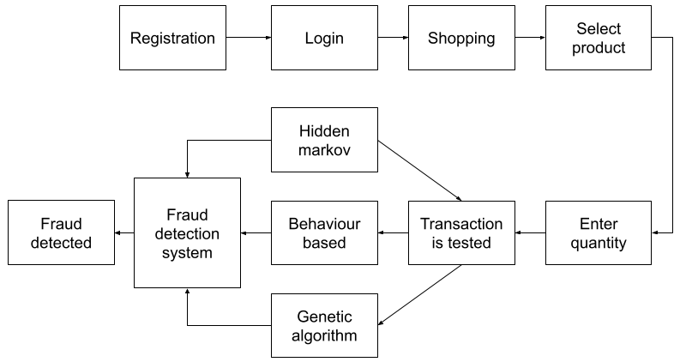
Fig: Class diagram on credit card fraud detection system

USE CASE DIAGRAM
Use case diagrams model the functionality of a system using actors and use cases. Use cases are services or functions provided by the System to its users.
BASIC USE CASE DIAGRAM SYMBOLS AND NOTATIONS:
System
Draw your system's boundaries using a rectangle that contains use cases. Place actors outside the system's boundaries.
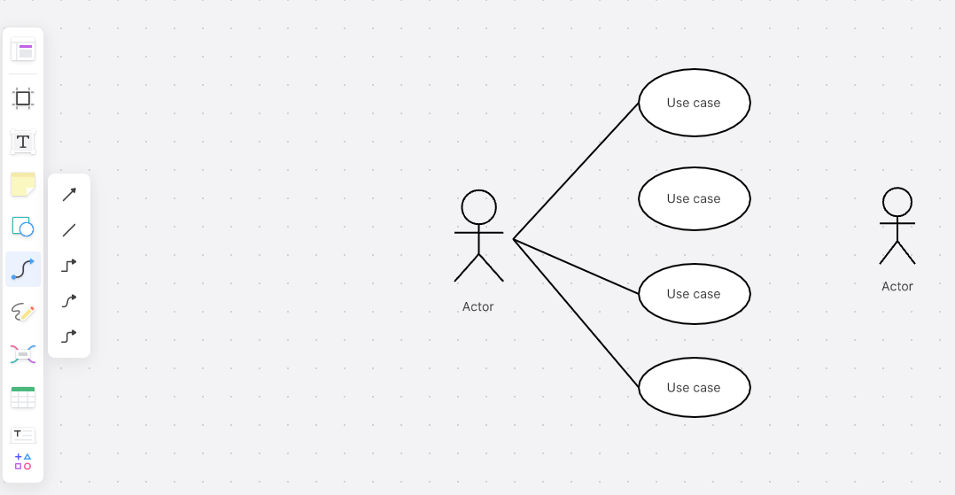

Use Case
Draw use cases using ovals. Label with ovals with verbs that represent the system's function.

Actors
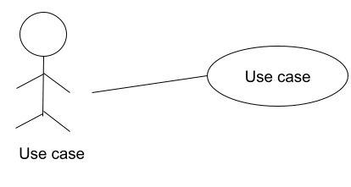

Relationships
The relationship between two use cases basically models the dependencies between two use cases. By reusing existing use cases using different types of relationships, the overall effort required to develop the system is reduced. Use case diagrams show use cases, actors, and the relationships between them.

USE CASE DIAGRAM
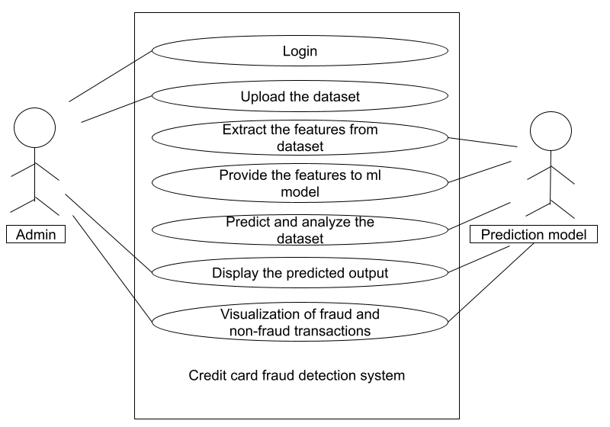

ACTIVITY DIAGRAM
An activity diagram is a type of Unified Modeling Language (UML) flowchart that shows the flow from one activity to another in a system or process. It's used to describe the different dynamic aspects of a system and is referred to as a behaviour diagram' because it describes what should happen in the modelled system.
Even very complex systems can be visualized by activity diagrams. As a result, activity diagrams are often used in business process modelling or to describe the steps of a use case diagram within organizations. They show the individual steps in an activity and the order in which they are presented. They can also show the flow of data between activities.
Activity diagrams show the process from the start (the initial state) to the end (the final state). Each activity diagram includes an action, decision node, control flows, start node, and end node.

SEQUENCE DIAGRAM
- UML Sequence Diagrams are interaction diagrams that detail how operations are carried out. They capture the interaction between objects in the context of a collaboration. Sequence Diagrams are time focus and they show the order of the interaction visually by using the vertical axis of the diagram to represent time what messages are sent and when. Model high-level interaction between active objects in a system
- Model the interaction between object instances within a collaboration that realizes a use case
- Model the interaction between objects within a collaboration that realizes an operation
- Either model generic interactions (showing all possible paths through the interaction) or specific instances of an interaction (showing just one path through the interaction)

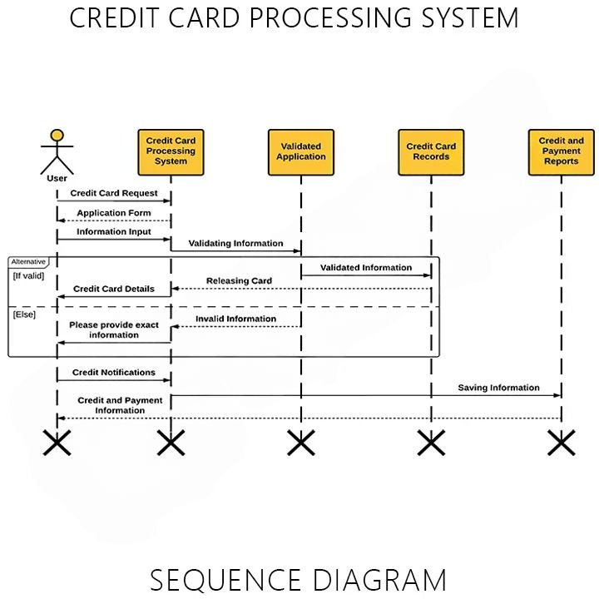

Fig: Credit Card Application Process Flow
5. SYSTEM TESTING AND IMPLEMENTATION

5. SYSTEM TESTING AND IMPLEMENTATION
INTRODUCTION:
System testing is a type of software testing that evaluates the overall functionality and performance of a complete and fully integrated software solution. It tests if the system meets the specified requirements and if it is suitable for delivery to the end-users. This type of testing is performed after the integration testing and before the acceptance testing.
System Testing is a type of software testing that is performed on a complete integrated system to evaluate the compliance of the system with the corresponding requirements. In system testing. integration testing passed components are taken as input. The goal of integration testing is to detect any irregularity between the units that are integrated together. System testing detects defects within both the integrated units and the whole system. The result of system testing is the observed behaviour of a component or a system when it is tested. System Testing is carried out on the whole system in the context of either system requirement specifications or functional requirement specifications or in the context of both. System testing tests the design and behaviour of the system and also, the expectations of the customer. It is performed to test the system beyond the bounds mentioned in the software requirements specification (SRS). System Testing is basically performed by a testing team that is independent of the development team that helps to test the quality of the system impartial It has both functional and non-functional testing. System Testing is a black-box testing. System Testing is performed after the integration testing and before the acceptance testing.

CREDIT CARD FRAUD DETECTION USING PREDICTIVE MODELING
Banks collect a lot of historical records corresponding to millions of customer's transactions.
They are credit card and debit card operations, but unfortunately, only a small portion, if any, is open access. Fraud detection is a critical problem affecting large financial companies that have increased due to the growth in credit card transactions [1]. The proposed method consists of the Predictive modelling and Logistic Regression. Now a day's bank transactions as well as credit card frauds increased. One of the most target frauds are credit card fraud, the fraud can occur any type of credit products, such products are retail, home loan and personal loan. During the last few decades as technology has changed, dramatically the face of fraud also changed. To detect credit card fraud, data mining techniques Predictive modelling and Logistic Regression are used. In prediction model to predict the continuous valued functions. Credit card of CSV files will be analysed to predict the outcome.
In this paper, we propose to detect credit card transaction using available data set and data mining techniques of predictive modelling. Decision tree, and Logistic Regression. Predictive modelling splits the data into two partitions 70% of testing and 30%of training check output class distribution to predict the outcome. The decision tree to get the result as a tree with root node describes the best predictor in the data, the combination of two or more branches is denoted by decision node (nonleafy nodes) and each branch represents a value for the attribute which is tested. The leaf node may be I in the case of fraud and 0 otherwise. Logistic regression or logistic model is a regression model, where the dependent variable is categorical of a linear generalized model. The rest of the paper is organized as explained. Section II describes fraud detection methods. Section III explains Dataset description for credit card transaction. Section IV consists of experimental results of fraud detection methods, and finally, the conclusion of this work included in section V.

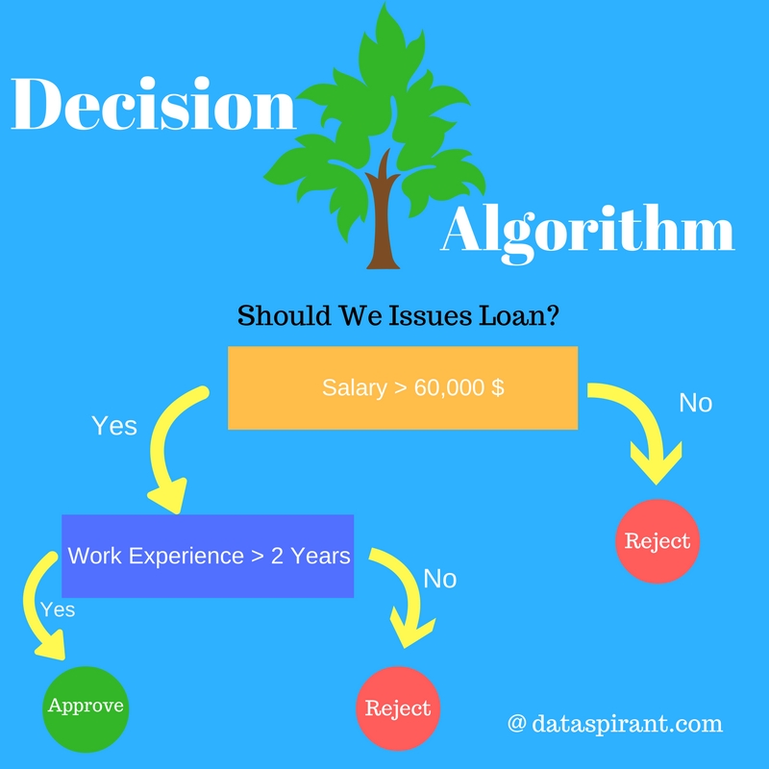
Fig: Decision Tree Algorithm

INTRODUCING TO DECISION TREE ALGORITHM
Decision Tree is a Supervised learning technique that can be used for both classification and Regression problems, but mostly it is preferred for solving Classification problems. It is a tree-structured classifier, where internal nodes represent the features of a dataset, branches represent the decision rules and each leaf node represents the outcome.
In a Decision tree, there are two nodes, which are the Decision Node and Leaf Node. Decision nodes are used to make any decision and have multiple branches, whereas Leaf nodes are the output of those decisions and do not contain any further branches. The decisions or the test are performed on the basis of features of the given dataset
It is a graphical representation for getting all the possible solutions to a problem/decision based on given conditions. It is called a decision tree because, similar to a tree, it starts with the root node, which expands on further branches and constructs a tree-like structure.

STRATEGIC APPROACH TO SOFTWARE TESTING
This reviews some of the common approaches in the integration testing of object-oriented program is also included. It helps in evaluating the effectiveness of testing by providing data on different coverage items. Different keywords were defined as a search string based on the research questions. These include Code Coverage. Software Testing, Prototype Testing, and Traceability. In this paper on the basis of current researches on software testing and preexisting approach of software strategy is described. Software is a critical element of software quality assurance and represents the ultimate review of specification, design and code generation. Software is tested from two different perspectives one, Internal program logic is exercised using "white box or glass box' test case design technique second, software requirement is exercised using 'black box test case design technique. This paper provides a study of current test coverage researches conducted by the other researches for test coverage in software testing. Testing is very important activity in software development process It is to examine and modify source code. This paper deals with a significant and important issue of testing. It is conducted basically manually as well as automated both have their own merits and demerits. Testing automation tools enables developers and testers to easily automate the entire process of testing in software development. This paper includes description about automated Testing tool such as Test Complete
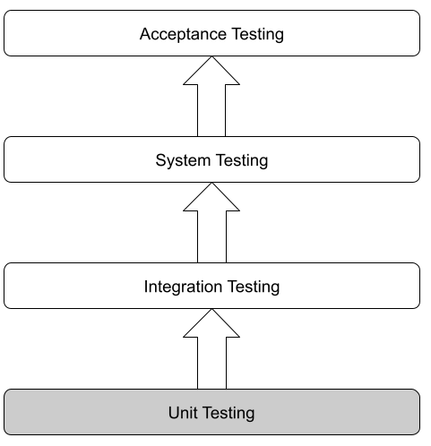
Fig: Levels of Software Testing

BLACK BOX TESTING
Black box testing is a software testing method where the tester assesses the functionality of a system without knowledge of its internal code or implementation details. The focus is on evaluating inputs and outputs, ensuring that the software behaves according to its specifications and requirements.

WHITE BOX TESTING
White box testing, also known as clear box testing or structural testing, is a software testing method that examines the internal structure and logic of a system. Testers have knowledge of the internal code, architecture, and design, allowing them to create test cases based on this understanding. The goal is to verify the correctness of the code, ensure all branches and paths are tested, and assess the overall system &amp; #39; s reliability.

UNIT TESTING
Unit testing is a software testing method where individual units or components of a software application are tested in isolation to ensure they function correctly. The focus is on verifying that each unit of code performs as intended and meets its design specifications. Unit tests are typically automated and are an essential part of the development process to catch and fix bugs curly in the software development lifecycle.
- Path testing
- Loop testing
- Condition testing
- Testing based on the memory perspective
- Test performance of the program

INTEGRATION TESTING
Integration testing in a software testing method that focuses on verifying the interactions between different modules or components of a system when integrated together. The primary goal is to identify and address issues that may arise from the combination of these components. Integration testing ensures that the units, when combined, work as expected and that data flows correctly between them. It helps detect interface defects, communication problems, and other issues that may arise from the interactions between integrated components.

ACCEPTANCE TESTING
Acceptance testing is a phase of software testing where a system is evaluated for its compliance with business requirements and whether it meets the acceptance criteria set by the stakeholders. It is the final phase before the software is deployed to a production environment Acceptance testing can be divided intotwo main types:
User Acceptance Testing (UAT): Conducted by end-users or clients to ensure that the software meets their business needs and requirements.
Business Acceptance Testing (BAT): Performed by business stakeholders to verify that the software aligns with the overall business objectives and goals.
The purpose of acceptance testing is to confirm that the software is ready for production use and that it satisfies the specified criteria agreed upon by both developers and stakeholders.

FUNCTIONAL TESTING
Functional testing is a type of software testing that evaluates the functions or features of a software application to ensure they work according to specified requirements. The primary focus is on verifying that the software performs its intended operations and produces the correct results. Functional testing can be performed at various levels of the software development life cycle and includes different types of testing such as unit testing, integration testing, and system testing. It aims to identify any deviations between the expected and actual behaviour of the software, covering aspects such as user interface, APIs, databases, security, and more.

BASIC PATH TESTING
Established technique of flow graph with cyclomatic complexity was used to derive test cases for all the functions. The flow graph and cyclomatic complexity are concepts closely related to software testing and code analysis. The flow graph is a graphical representation of a program's control flow, while cyclomatic complexity is a quantitative measure of the complexity of a program.
V(G)-E-N+2 or
V(G) P+1 or
V(G) Number Of regions
Where V(G) is cyclomatic complexity,
E is the number of edges,
N is the number of flow graph nodes.
P is the number of predicate nodes

CONDITIONAL TESTING
Conditional testing is a software testing technique that specifically focuses on validating the correct execution of conditional statements within a program. Conditional statements, such as if statements and switch-case constructs, introduce decision points in the code where different paths can be taken based on the evaluation of specified conditions. Conditional testing aims to ensure that the program behaves as expected under various conditions, including both true and false outcomes of the conditions.

DATA FLOW TESTING
Data flow testing is a software testing technique that focuses on the analysis of how data is transmitted and transformed within a program. The primary goal of data flow testing is to identify and exercise paths through the program based on the flow of data. This technique is particularly useful for detecting potential data-related issues, such as uninitialized variables, data dependencies, and incorrect data transformations.

LOOP TESTING
Loops are control structures that repeat a specific block of code until a certain condition is met. The goal of loop testing is to ensure that loops function correctly under various conditions. including normal and boundary cases, and to identity and address any potential issues associated with loop execution
- Identify all loops in the program
- Design test cases to cover both true and false conditions for loop entry
- Design test cases to cover both true and false conditions for loop exit.
- Ensure that loops include the expected number of times.
- Test scenarios with different loop entry and exit conditions.

Alpha testing in Google Play Store
Alpha testing an app means releasing it to a controlled users’ groups which are not necessarily associated with the development of the app itself.
Google Play Store provides "Closed testing" tracks where you can run alpha tests for your Android app. Each type of testing in Play Stere is a track, a track can have multiple releases pertaining to different versions of the app that you release for the specific type of testing. App versions released on a certain track are indexed by their gridle-configured version Code, while the version Name string remains a variable name for the versions release on the track.
To get going with Alpha testing/Closed testing in Google Play Store, you must first release a software build of your app on the track. If you have not used it before, just navigate over to the Play Store console, select your app and then the relevant testing type (track) from the left-hand panel.
Testing Cases
1 | Check response of end points | Send correct request to every Endpoint | Correct response | pass
2 | Check response of end points | Send invalid request GET instead of POST | 405-method not allowed | pass
3 | Check response of end points | Send request to wrong Endpoint | Error message should display as incorrect details | pass
4 | Check response of end points | Send request to no Endpoint | 404- page not found | pass
5 | Check interaction between end points | Send a request to an end point that call | Correct response | pass
6 | Check data ingestion into HDFS | Send a batch to load into HDFS | File gets added | pass

6. SYSTEM SECURITY

6.SYSTEM SECURITY
The protection of computer-based resources that include hardware, software, data, procedures and people against unauthorized use or natural Disaster is known as system security.
System security can be divided into four related issues
- Security
- Integrity
- Privacy
- Confidentiality

SYSTEM SECURITY
System security refers to the set of measures and safeguards implemented to protect computer systems, networks, and data from unauthorized access, attacks, damage, or any form of unauthorized interference. The primary goal of system security is to ensure the confidentiality, integrity, and availability of information and resources within a computing environment.

DATA SECURITY
Data security refers to the set of practices, technologies, and policies implemented to protect digital data from unauthorized access, disclosure, alteration, destruction, or other forms of compromise. The primary pool of data security is to ensure the confidentiality, integrity, and availability of sensitive information.

PRIVACY
Defines the rights of the user or organization to determine what information they are willing to share with or accept from others and how the organization can be protected against unwelcome unfair or excessive dissemination of unformation about it.

CONFIDENTIALITY
It is a special status given to sensitive information in a database to minimize the possible invasion of privacy. It is an attribute of information that characterizes its need for protection.
Types of System Threats -
Aside from the program threats, various system threats are also endangering the security of our system:

1. Worm:
An infection program that spreads through networks. Unlike a virus, they target mainly LANS A computer affected by a worm attacks the target system and writes a small program "hook” on it. This hook is further used to copy the worm to the target computer. This process repeats recursively, and soon enough all the systems of the LAN are affected. It uses the spawn mechanism to duplicate itself. The worm spawn's copies of itself, using up a majority of system resources and also locking out all other processes.
The basic functionality of the worm can be represented as
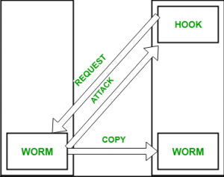
Fig: The basic functionality of the worm
2. Port Scanning:
It is a means by which the cracker identifies the vulnerabilities of the system to attack. It is an automated process that involves creating a TCP/IP connection to a specific port. To protect the identity of the attacker, port scanning attacks are launched from Zombie Systems, that is systems that were previously independent sisters that are also serving their owners while being used for sech notorious purposes.
3. Denial of Service:
Such attacks aren't aimed for the purpose of collecting information or destroying system files. Rather, they are used for disrupting the legitimate use of a system or facility.

These attacks are generally network-based. They fall into two categories:
-Attacks in this first category use so many system resources that no useful work can be performed. For example, downloading a file from a website that proceeds to use all available CPU ime
-Attacks in the second category involve disrupting the network of the facility. These attacks are a result of the abuse of some fundamental TCP/IP principles.
The fundamental functionality of TCP/IP.
Security Measures Taken -
To protect the system, Security measures can be taken at the following levels:
- Physical:
The sites containing computer systems must be physically secured against armed and malicious intruders. The workstations must be carefully protected
- Human:
Only appropriate users must have the authorization to access the system. Phishing (collecting confidential information) and Dumpster Diving (collecting basic information so as to gain unauthorized access) must be avoided.
- Operating system:
The system must protect itself from accidental or purposeful security broaches
- Networking System:
Almost all of the information is shared between different systems via a network.
Intercepting these data could be just as harmful as breaking into a computer. Henceforth, Network should be properly secured against such attacks.
Usually, Anti Malware programs are used to periodically detect and remove such viruses and the cats. Additionally, to protect the system frame Network Threats, a Firewall is also used.

7. SOFTWARE ENVIRONMENT

7.1 USED LANGUAGES
The software development environment encompasses a variety of programming languages. Each designed for specific purposes and use cases. We used python as programming language. Python is a beginner's language, which provides various applications.
In recent years, python had set the new trend because it is easy to use, interpreted, object-oriented, high-level, scripting language.

7.1.1WHAT IS PYTHON
Python is a high-level, general-purpose programming language that emphasizes readability and ease of use. It was created by Guido van Rossum and first released in 1991. Python supports multiple programming paradigms, including procedural, object-oriented, and functional programming. It has become one of the most popular programming languages, known for its simplicity, versatility, and a large, active community of developers. Python language is being used almost all tech-giant companies like-Google, Amazon, P'acebook, Instagram, Dropbox.
Uber……etc. The biggest strength of python is huge collection of standard libraries which can be used for the following-
- Machine Learning
- GUI Applications (like Kivy, printer, Pyt etc.)
- Web frameworks like Django (used by you tube. Instagram, Dropbox)
- Image processing (like OpenCV, pillow)
- Web scraping (like Scraру)
- Test frameworks
- Multimedia

7.1.2 HISTORY OF PYTHON
Guido van Rossum started working on Python as a holiday project during December 1989. The language is developed as a successor to the ABC language, which Guido had worked on at Centrum Wickenden & Informatica (CWT) in the Netherlands.
The first official release of Python, version (1.9.0, was released in February 1991.It includes features like exception handling, functions, and modules. Python 1.0 was released in January 1994.This version includes many features that are still part of Python today, such as lambda, map, filter, and reduce functions.
Python 2.0 was released in October 2000.Introduces list comprehensions, garbage collection, and Unicode support.
Python 3.0, also known as "Python 3000" or "Py3k," was released in December 2008.This release is a major, backward-incompatible revision, addressing design flaws and introducing new features.
The Python Software Foundation was established in 2001 as a non-profit organization to promote, protect, and advance Python and its community.
Python gained popularity in the 2000s and 2010s, becoming one of the most widely used programming languages. Its readability, versatility, and extensive libraries contribute to its adoption in various domains, including web development, data science, artificial intelligence, and more.

7.1.3 PYTHON FEATURES
Python is a powerful, high-level programming language with a variety of features that contribute to its popularity. Here are some key features of Python:
Readability: Python emphasizes code readability and a clean syntax. The use of indentation instead of braces for block delimiters enforces a clear and consistent coding style.
Simplicity: Python's simple and easy-to-leam syntax makes it an ideal language for beginners. It allows developers to express concepts in fewer lines of code compared to languages like C++ or Java.
Versatility: Python supports multiple programming paradigms, including procedural, object oriented, and functional programming. This versatility makes it suitable for a wide range of applications.
Interpreted Language: Python is an interpreted language, allowing for rapid development and testing. Developers can run code line by line in an interactive mode.
Dynamically Typed: Python is dynamically typed, meaning that variable types are interpreted during runtime. This flexibility simplifies code development but requires careful attention to variable types.
High-Level Data Structures: Python comes with built-in high-level data structures such as lists, dictionaries, sets, and tuples. These structures simplify the implementation of complex algorithms and data manipulation tasks.
Extensive Standard Library: Python includes a comprehensive standard library with modules and packages for various tasks, reducing the need for external dependencies.
Community and Documentation: Python has a large and active community of developers. Extensive documentation and community support make it easy to find solutions to problems and share knowledge.

7.1.4 ADVANTAGES OF PYTHON OVER OTHER LANGUAGES
Readability and Simplicity: Python's syntax is clean, clear, and easy to read. This readability makes it an excellent language for beginners and experienced developers alike.
Ease of Learning: Python's simple and straightforward syntax makes it easy for beginners to learn. The reduced complexity allows developers to focus on problem-solving rather than dealing with intricate language details.
Versatility and Flexibility: Python supports multiple programming paradigms, including procedural, object-oriented, and functional programming. It can be used for a wide range of applications, from web development to data science and artificial intelligence.
Extensive Standard Library: Python comes with a comprehensive standard library that provides modules and packages for various tasks. This reduces the need for developers to write code from scratch and accelerates the development process.
Community and Documentation: Python has a large and active community of developers who contribute to its growth and support. Extensive documentation and community resources make it easy for developers to find help and solutions to problems.
Cross-Platform Compatibility: Python is platform-independent, meaning that Python code can run on different operating systems without modification. This enhances the portability of Python applications.

8. RESULTS AND PERFORMANCE ANALYSIS

8. RESULTS AND PERFORMANCE ANALYSIS
The primary goal of any performance testing is to provide a clear status on application performance and to identify performance issues (if any). Performance Test Result Analysis is crucial because a wrong prediction or a decision to go live with risk may impact revenue, brand, market perception and user experience.
Performance Test Result Analysis is the most important and technical part of performance testing rather than scripting and execution. A performance tester requires his actual expertise to carry out the test result analysis phase and conclude the testing. This phase is also important because a performance tester has a list of dependent tasks to perform in this phase like analysing the graphs, checking the metrics, find-out the bottlenecks, comparing the result with defined NFRs and at last, concluding the test result. A small mistake in the result analysis may cause a big disaster in the live environment. That mistake could be due to a lack of experience. Hence a senior performance tester or manager has to review the performance test results before concluding and out for the client.

8.1 ANALYSIS:
Analysis Model is a technical representation of the system. It acts as a link between system description and design model. In Analysis Modelling, information, behaviour, and functions of the system are defined and translated into the architecture, component, and interface level design in the design modelling.
Software analysis and design includes all activities, which help the transformation of requirement specification into implementation. Requirement specifications specify all functional and non-functional expectations from the software. These requirement specifications come in the shape of human readable and understandable documents, to which a computer has nothing to do.
Software analysis and design is the intermediate stage, which helps human-readable requirements to be transformed into actual code.
8.1.1 USING MACHINE LEARNING:
Machine learning constitutes model-building automation for data analysis. When we assign machines tasks like classification, clustering, and anomaly detection — tasks at the core of data analysis — we are employing machine learning.
We can design self-improving learning algorithms that take data as input and offer statistical inferences. Without relying on hard-coded programming, the algorithms make decisions whenever they detect a change in pattern.
Ubuntu offers a better option for security and privacy as compared to Windows. The best benefit of having Ubuntu is that we can inherit the needed privacy and extra security without having any solution from a third party.
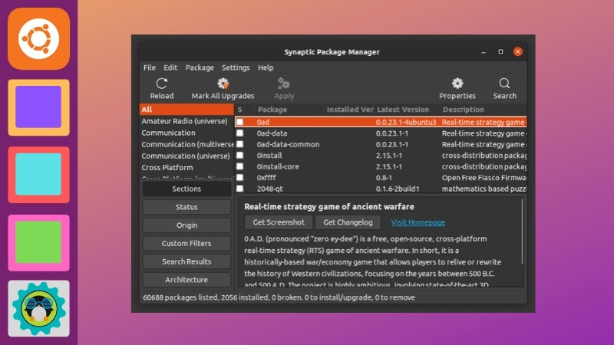
Fig: Top free applications
Before we look at specific data analysis problems, let’s discuss some terminology used to categorize different types of machine-learning algorithms. First, we can think of most algorithms as either classification-based, where machines sort data into classes, or regression-based, where machines predict values.
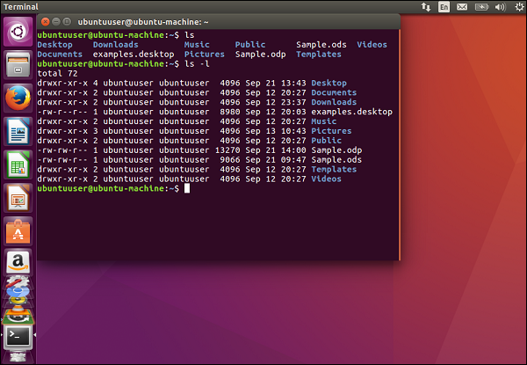
Fig: Top paid applications
Next, let’s distinguish between supervised and unsupervised algorithms. A supervised algorithm provides target values after sufficient training with data. In contrast, the information used to instruct an unsupervised machine-learning algorithm needs no output variable to guide the learning process.
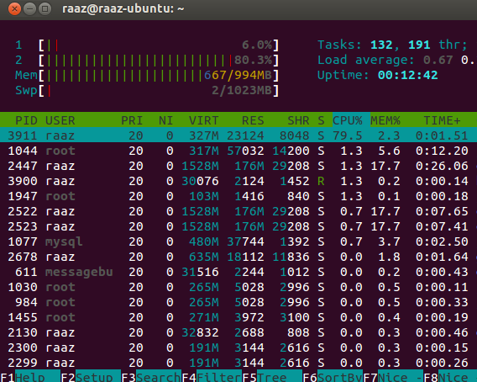
Fig: Top reviewed applications

Data analysts contribute to data driven decision making and offer valuable insights and recommendations to help companies secure a competitive advantage in their field The tasks range from technical organization and analytical work to collaboration and communication to non-technical stakeholders.
To be successful in their role, analysts must be proficient in data analysis tools and techniques, be detail oriented, and possess strong soft skills to help communicate their findings to relevant stakeholders. Many data analysts today look to improve their skills through data analysis courses or verify their skill sets by securing a data analyst certificate.
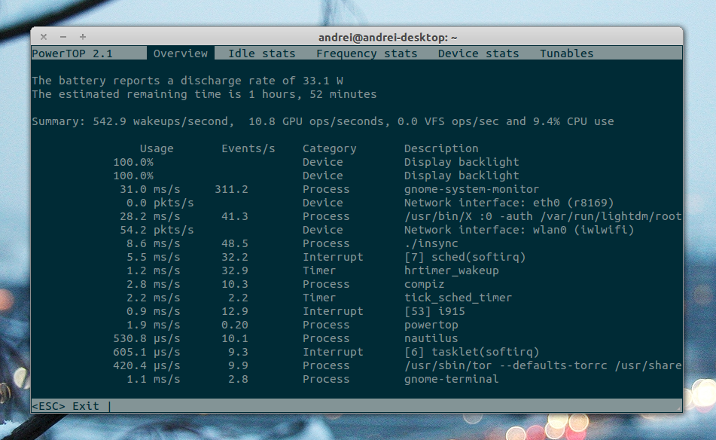

Fig: Editor’s choice apps

8.2 PREDICTION:
Reliability prediction is useful in a number of ways. A prediction methodology provides a uniform, reproducible basis for evaluating potential reliability during the early stages of a project. Predictions assist in evaluating the feasibility of proposed reliability requirements and provide a rational basis for design and allocation decisions.
Hardware reliability prediction provides a constant failure rate value for the "inherent reliability" of the product, the estimated reliability attainable when all design and production problems have been worked out. A hardware reliability growth model is used to monitor product reliability in the period during which the observed reliability advances toward the inherent reliability.

8.3 DEEP LEARNING OVER MACHINE LEARNING:
Artificial Intelligence is in a rage! All of a sudden, everyone, whether they understand or not, is talking about it. Understanding the latest advancements in artificial intelligence can seem overwhelming, but it really boils down to two very popular concepts: Machine Learning and Deep Learning. But lately, Deep Learning is gaining much popularity due to its supremacy in terms of accuracy when trained with a huge amount of data.
Practically, Deep Learning is a subset of Machine Learning that achieves great power and flexibility by learning to represent the world as nested hierarchy of concepts, with each concept defined in relation to simpler concepts, and more abstract representations computed in terms of less abstract ones.

9. SCREENSHOTS

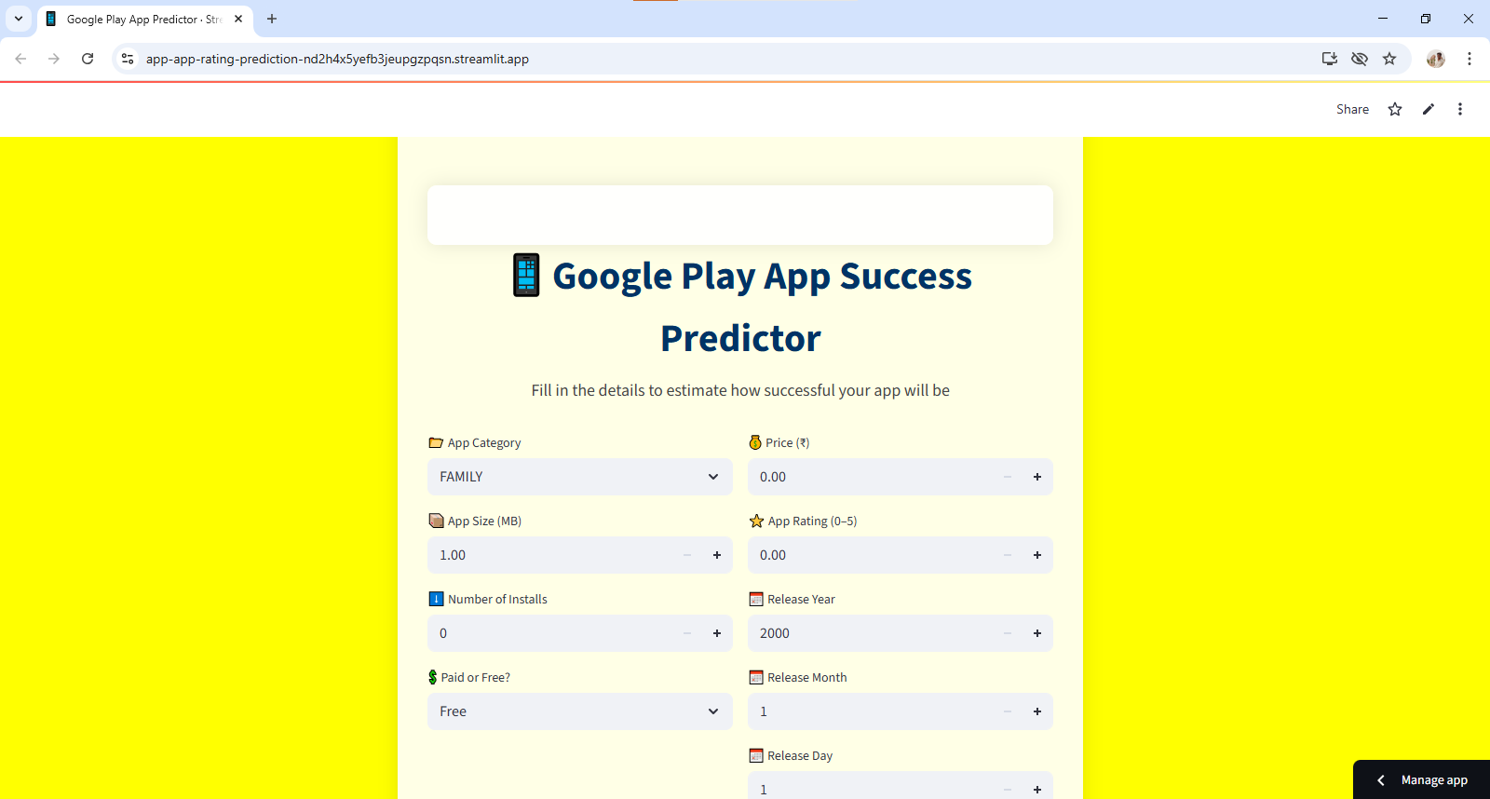
Fig: Screenshot after successful deployment
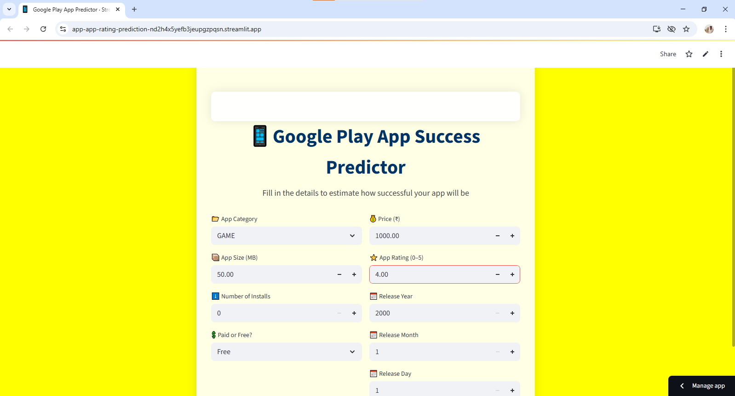
Fig: Screenshot while giving input

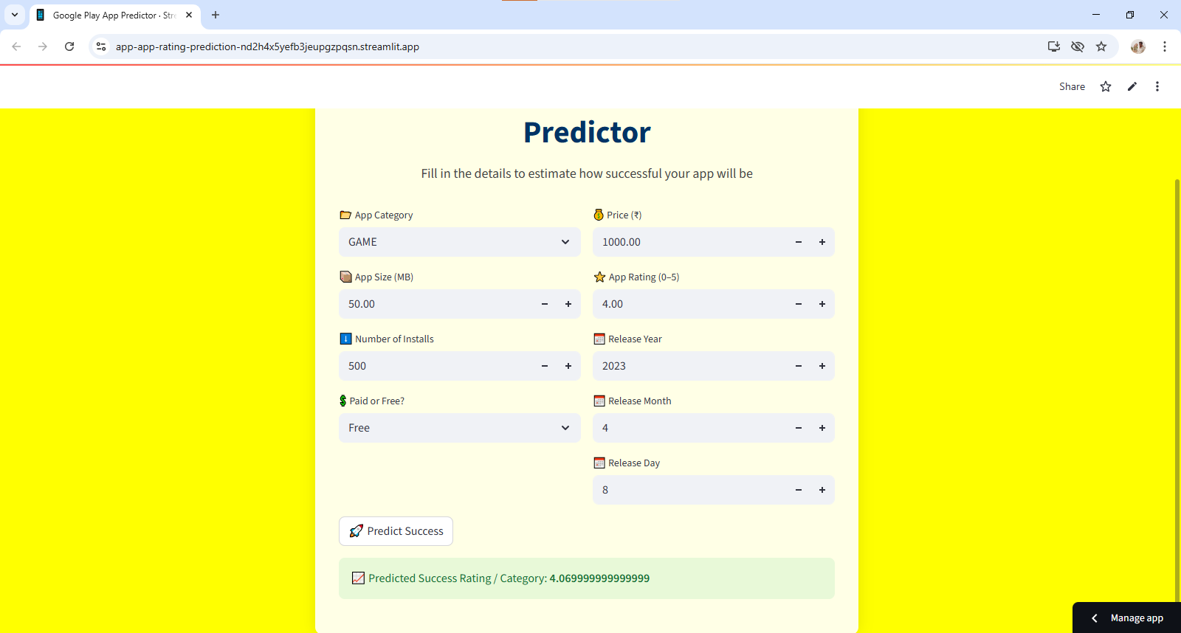
Fig: Image after successful prediction

10. CONCLUSION

10. CONCLUSION
Google Play, a major app store, is the subject of this study, which examines trends over time. Using a variety of hacking techniques, we've created Play Drone, a system that can successfully search through Google Play. Adding more servers is all it takes for Play Drone to grow, and it's fast enough to crawl Google Play every day, downloading and decompiling over 1.1 million Android apps. With Play Drone, we can characterise Android apps in Google Play on a massive scale and show how the content of apps changes over time, despite Google Play having thousands of apps, only a small percentage of those are free, despite the fact that free apps account for the vast majority of downloads. Customers at risk were identified and alerted by working with service providers such as Amazon, Facebook and Google. Use Play Drone to better understand Android apps and improve the quality of content in Google Play, as demonstrated by these results According to the results of this research, 'family' and 'games' apps in the Google Play store are the most downloaded.

11. BIBLIOGRPHY

BIBLIOGRPHY
A bibliography for Google Play Store app rating prediction would include research papers and projects that utilize machine learning and data analysis techniques to forecast app ratings based on various features. Key references often include:
Research Papers on Machine Learning and NLP for App Rating Prediction:
- Vijayanarayanan, A., Savithiri, R., Lekha, P., & Abbirami, R. S. (2023). Google Play store Reviews Prediction Using ML And NLP. Journal of Science, Computing and Engineering Research, 6(4), 61-67. This paper focuses on using machine learning and natural language processing (NLP) to predict app ratings based on user reviews.
Academic Projects and Repositories:
- Prathmesh444. (n.d.). Play-Store-App-Rating-Prediction. GitHub. This GitHub repository details a project that builds a model to predict Google Play Store app ratings using parameters like installs, reviews, size, category, and genres, comparing various classification models like XGBoost, Random Forest, Logistic Regression, and Support Vector Machines.
Data Analysis and Prediction Studies:
- Researchgate. (2024). Play Store App Analysis & Rating Prediction Using Classical ML Models Artificial Neural Network. This work explores app rating prediction using classical machine learning models and artificial neural networks, providing insights into data characteristics and model performance.
Relevant Datasets and Project Documentation:
- Scribd. (n.d.). App Rating Prediction Project | PDF. This document outlines a project involving Google Play Store data analysis for app rating prediction, discussing data cleaning, feature engineering, and model development steps.
These resources collectively offer a comprehensive view of the methodologies and findings in the field of Google Play Store app rating prediction, covering data sources, feature selection, model building, and performance evaluation.

